**Test Report - ECE 458, Spring 2020**

**Group 9 - Acoustic Awareness Enabler**

University of Massachusetts Dartmouth

|  |  |
| --- | --- |
| *Professor:* | Dr. Paul Fortier |
| *Customer:* | Dr. Karen Payton |
| *Advisor:* | Dr. Vance McCollough |

***­­­****Group Members:*

|  |  |
| --- | --- |
| Drew Martins: | Team Lead and Programmer |
| Stephen Felix: | Test Engineer |
| Ryan Dumont: | Electrical Design Engineer |
| Michael Benker: | | Systems Engineer |
| Jared Alves: | Signal Processing Engineer |

Due date: 3/27/2020

Table of Contents

List of Figures 2

List of Tables 3

System Overview 4

Background 4

Project Objectives 4

Concept of Operations 5

Engineering Requirements 8

Verification Cross Reference Matrix (VCRM) 8

Test Plans Overview and Flowchart 9

Test Plan Flow Chart 10

Test Plan Verification Matrix 11

Test Plans: Electronics 13

Test Plans: Processing 28

Test Plans: Coding 35

Test Plans: Printed Circuit Board 41

Test Plans: Enclosure 46

Test Summary and Comments 49

Project Impacts Associated with the COVID-19 Pandemic 51

COVID-19 Risk Mitigation Plans 52

Updated Plan and Schedule 54

Figures and Attachments 56

Figures: Electronics Testing 56

Figures: Processing Testing 60

Figures: Coding Testing 66

Figures: Printed Circuit Board Testing 66

Figures: Enclosure Testing 67

ADC Test Code (C) 69

# List of Figures

Figure 1 Design Concept 5

Figure 2 Software Diagram 6

[Figure 3 Concept of Design 7](https://umassd-my.sharepoint.com/personal/mbenker_umassd_edu/Documents/ECE458%20Design%20Project/ECE-9%20Test%20Report.docx#_Toc36149023)

Figure 4 Device Example 7

[Figure 5 Test Plan Flowchart 10](https://umassd-my.sharepoint.com/personal/mbenker_umassd_edu/Documents/ECE458%20Design%20Project/ECE-9%20Test%20Report.docx#_Toc36149025)

Figure 6 Microphone Circuit 55

Figure 7 Microphone Test 55

Figure 8 Amplifier Test Plan Circuit 56

Figure 9 Amplifier 50mV Input 56

Figure 10 Microphone & Amp Integration 57

Figure 11 Microphone and Amplifier Integration Circuit 57

Figure 12 Digital Switch Testing Circuit 58

Figure 13 Auxillary Switch Test 58

Figure 14. Data Collected using Sound Meter in One Environment 59

Figure 15. Data Plot with Sound Meter 59

Figure 16. Standard Deviations of Environment 60

Figure 17. Multiple Environments 60

Figure 18. Average Standard Deviations of Each Threshold Level 61

Figure 19 Standard Deviation vs Ambient 61

Figure 20 Threshold based on Standard Deviation 62

Figure 21 PT_04 Successful Interrupt 62

Figure 22 30 second average vs 3 second average 62

[Figure 23 Iterative Averaging 62](https://umassd-my.sharepoint.com/personal/mbenker_umassd_edu/Documents/ECE458%20Design%20Project/ECE-9%20Test%20Report.docx#_Toc36149043)

Figure 24 Call Iterative 63

Figure 25 Recursive Average Result 63

Figure 26 Iterative Averaging Result 63

Figure 27 Recursive Methods 64

Figure 28 Average Timing 64

Figure 29 ADC Test Code 65

Figure 30. PCB Test Layout for Maximum Constraint Size (3500mil x 2000mil 66

Figure 31 Enclosure Outline 67

Figure 32. Selected Enclosure: Hammond 2138222 68

# List of Tables

Table 1 Customer Requirements 3

Table 2 Verification Cross Reference Matrix 7

Table 3 Test Plan Verification Matrix 10

Table 4 Test Summary 48

# System Overview

## Background

The idea of the Acoustic Awareness Enabler is reported to have resulted from an incident in which the customer was watching a movie on her laptop with headphones. Her husband had called for her to respond, but she was unaware of this, her attention drawn to her computer. She thought then, what if there was a way for her headphones to let her know if someone was trying to get her attention? This was the apparent beginning of the Acoustic Awareness Enabler. Senior Design Project Group 9 seeks to realize this idea to a working device, capable of alerting a user wearing headphones to an external acoustic event.

## Project Objectives

The primary objective of the Group 9 Senior Design Project is to build a device known as the Acoustic Awareness Enabler, which is described as follows. The Acoustic Awareness Enabler is a device that is positioned between two auxiliary cables leading from an audio source to headphones. The device listens to outside noises and alerts the user (i.e. wearing headphones) to the unusually loud sound by turning off the audio throughput. The device uses three sensitivity settings, which provide the user with a selection of necessary threshold sound level (relative to surrounding environment) needed to pause the audio. The following were outlined as customer requirements for the Acoustic Awareness Enabler:

Table 1 Customer Requirements

|  |  |
| --- | --- |
| **Cust. Req. #** | **Customer Requirements Description​** |
| 1 | Self-containment of power source (rechargeable) and battery life of 8 hours​ |
| 2 | 3.5mm audio jack for input and output​ |
| 3 | Must have 3 different levels of interruption noise sensitivity (High, Medium and Low sensitivity) ​ |
| 4 | When interruption is detected, the volume of the noise going through users’ headphones must be muted or lowered​ |
| 5 | Must be able to distinguish between ambient and interrupt with a 1% false interrupt detection rate​ |
| 6 | Must have a reset button to restart audio ​ |
| 7​ | Separate audio cable between device and audio source​ |

## Concept of Operations

In terms of user interaction with the Acoustic Awareness Enabler, there arise only the following situations: turning the device on or off, changing the sensitivity threshold and resetting the device to start a new cycle of data collection or to turn the audio back on after it was turned off as a result of an interrupt.

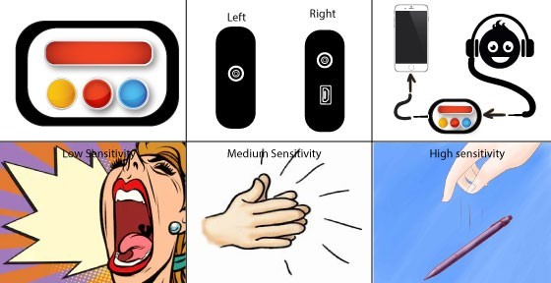

Figure 1 Design Concept

Behind the scenes, the Acoustic Awareness Enabler is taking in acoustic data and testing whether a recent level exceeds a threshold level calculated from the average and standard deviation of a longer period of data. If the device finds that the sound level has not been exceeded, it will replace the oldest data set with the most recent and calculate the average and standard deviation continuously and test if a yet more recent sound will exceed a new threshold. If the threshold is exceeded, the device will turn off the audio throughput to the headphones. The Software Diagram flowchart outlines how the device works “under the hood”. In attempt to outline how the Acoustic Awareness Enabler works functionally, a matrix was constructed to outline what events would be triggered at which time under all possible conditions. Finally, a high-level schematic was designed to give an overview of what hardware would be used to build the Acoustic Awareness Enabler.

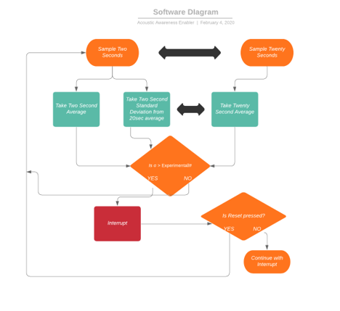

Figure 2 Software Diagram

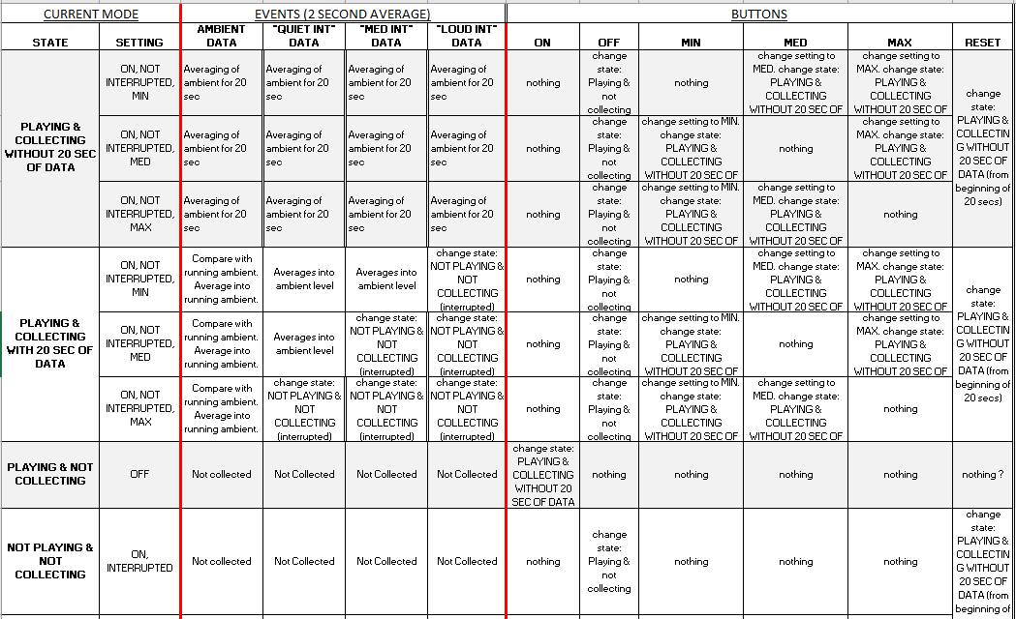

Figure 3 Concept of Design

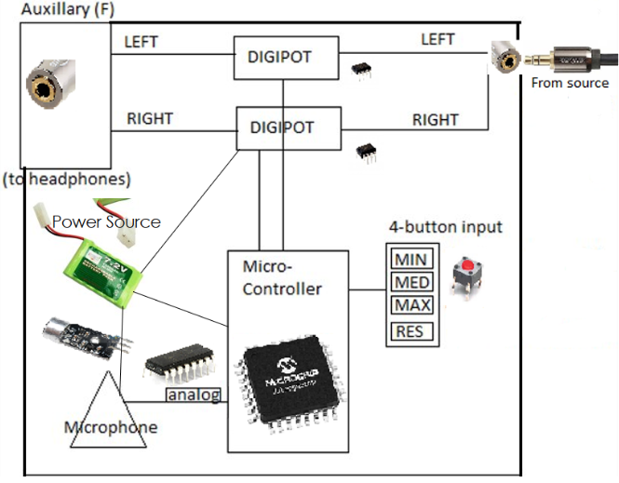

Figure 4 Device Example

# Engineering Requirements

## Verification Cross Reference Matrix (VCRM)

Presented below are the current engineering requirements. There has not been any significant change to the Engineering Requirements since the Preliminary Design Review (PDR), however some of the language has been updated to reflect consistency with respect to what has been completed already and to avoid confusion with current engineering decisions. A new column is added to reflect the related Test Plans associated with each Engineering Requirement and further, how Test Plans are used to verify an Engineering Requirement; either by inspection, analysis, demonstration, test or a combination of these verification methods. Where needed, further explanation is provided in the final column to clarify how the proposed Test Plans will prove satisfactory for each Engineering Requirement.

Table 2 Verification Cross Reference Matrix

|  |  |  |  |  |  |  |  |  |
| --- | --- | --- | --- | --- | --- | --- | --- | --- |
| **Cus.Req. #** | **Eng. Req. #** | **Engineering Requirement Description** | **Related Test Plan Codes** | **Verification** | | | | **Where met in design** |
| **I** | **A** | **D** | **T** |
| 1​ | 1.1 | 8 hours of power supplied to device​. | ET_09, ET_13, ET_15 |  |  | X | X | Power supplied by battery. |
| 2​ | 2.1 | Audio Source Input 3.5mm ​ | ET_04, NT_02 | X |  | X |  | Interface of enclosure and electronics. |
| 2.2 | Audio Source Output 3.5mm​ | ET_04, NT_02 | X |  | X |  |
| 2.3 | I/O interface – digital switch​ | ET_03, ET_07, | X |  |  | X | Digital Switch found in electronics and controlled by µC. |
| 3​ | 3.1 | Processing includes average and standard deviation calculations to determine threshold | PT_01, PT_02, PT_03 |  | X | X |  | Process first validated in external software then programmed in µC. |
| 3.2 | Three separate sensitivity buttons | ET_05, PT_01 |  | X |  | X | Interface of enclosure and electronics. |
| 4​ | 4.1 | Digital switches turn off audio throughput when interruption threshold is exceeded. | ET_10, ET_11, ET_12 |  |  |  | X | µC reads acoustic signals and alerts when threshold exceeding, sending a signal to the digital switch. |
| 5​ | 5.1 | Digital signal processing is invoked to determine the presence of an outlier in a set of acoustic level readings. ​ | PT_04, CT_01, CT_04, CT_05 |  |  | X |  | Process first validated in external software then programmed in µC. |
| 5.2 | Lowest Ambient Noise of 30 dB based on ANSI standards | ET_01, PT_01 |  | X |  | X | Microphone meeting requirement is selected, signal processing design in accordance. |
| 5.3 | Must have 100 Hz Sampling frequency to detect averages in sound (not reconstructing signal) ​ | CT_05 |  |  | X |  | At the interface of the ADC on µC and analog input from microphone and analog electronics. |
| 5.4 ​ | Need a sound level detector | ET_01 |  |  |  | X | Microphone is used. |
| 6​ | 6.1 | Physical reset button will be present on Acoustic Awareness Enabler to reset acoustic environment data. ​ | ET_05, NT_02 |  |  | X | X | Button pressed sends signal to µC to turn switch on after being off. If switch is on, clear processing data. |
| 6.2 | Use of switches to resume audio after reset button has been pressed. ​ | ET_10 |  |  |  | X | Button pressed sends signal to µC to turn switch on after being off. |
| 6.3 | Button will recalibrate device and will delay further interrupts for 20 seconds while gathering data​ | ET_11, PT_03 |  |  | X | X | If switch is on, clear processing data. Set 20 second pause on interrupts. |
| 7​ | 7.0 | Audio (auxiliary) Cable Included with Enclosure | ET_04 | X |  |  |  | Include test auxiliary cable. |

# Test Plans Overview and Flowchart

The use of test plans offers immense benefits to a design project. For instance, test plans allow for greater ease in troubleshooting by allowing a team member to trace their steps back to resolve an issue. A project is made verifiable with test plans, which increases the trust of the customer. The process of building test plans, by forcing the team to review their future actions in detail, improve the accuracy at which a team can predict the amount of time required to complete the project, in addition to anticipating potential pitfalls before they appear.

The test plans for the Acoustic Awareness Enabler are organized into the following categories: electronics, processing, coding, printed circuit board and enclosure. Testing is needed for all these components of the project. By no means does the categorization of a particular test plan exclude it from interacting with other test categories, however since all test plans contribute to the final goal which is a blend of all categories.

## Test Plan Flow Chart

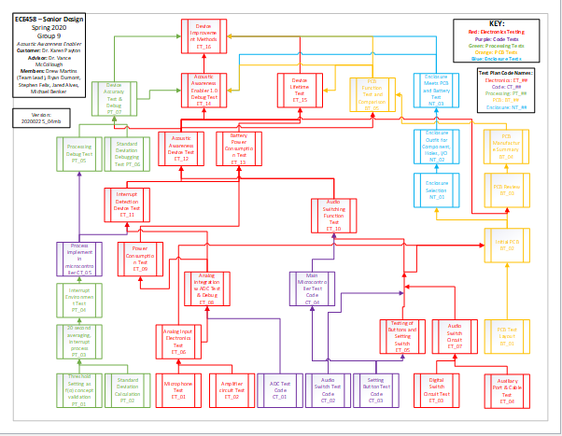It was also decided that most test plans require a prerequisite test plan. To cleanly outline the order in which test plans need to be made, a flowchart has been constructed:

Figure 5 Test Plan Flowchart

## Test Plan Verification Matrix

A Verification Cross Reference Matrix is useful for identifying how Engineering Requirements are met using various Test Plans. A verification matrix may also be constructed as a high-level document outlining how each Test Plan proves useful to the completion of the project through satisfying an Engineering Requirement. It also provides an overview for all Test Plans and the proposed verification methods of each test.

Table 3 Test Plan Verification Matrix

|  |  |  |  |  |  |  |
| --- | --- | --- | --- | --- | --- | --- |
| **Test Code** | **Test Name** | **Verification Method** | | | | **Prerequisite Test(s)** |
| **I** | **A** | **D** | **T** |
| ET_01 | Microphone Test |  |  |  | T | None |
| ET_02 | Amplifier Circuit Test |  |  |  | T | None |
| ET_03 | Digital Switch Test |  |  |  | T | None |
| ET_04 | Auxiliary Port and Cable Test | I |  |  |  | None |
| ET_05 | Testing of Buttons and Switch |  |  |  | T | None |
| ET_06 | Analog Input Electronics Test |  |  |  | T | ET_01, ET_02 |
| ET_07 | Audio Switch Test | I |  |  |  | ET_03, ET_04 |
| ET_08 | Analog Integration w ADC Test and Debug |  |  |  | T | ET_06, CT_01 |
| ET_9 | Power Consumption Test |  |  |  | T | ET_08 |
| ET_10 | Audio Switching Function |  |  |  | T | ET_07, CT_04 |
| ET_11 | Interrupt Detection Device |  |  |  | T | ET_08, CT_05 |
| ET_12 | Acoustic Awareness Device |  |  |  | T | ET_10, ET_11 |
| ET_13 | Battery Power Consumption |  |  |  | T | ET_09, ET_10, ET_11 |
| ET_14 | Acoustic Awareness Enabler 1.0 Debug Test |  |  |  | T | ET_12, PT_07, BT_05, NT_03 |
| ET_15 | Device Lifetime Test |  |  |  | T | ET_12, ET_13, BT_05 |
| ET_16 | Device Improvement Methods | I |  |  |  | ET_14, ET_15, PT_07, BT_05, NT_03 |
| PT_01 | Threshold Setting as f(σ) Concept Validation |  | A |  |  | None |
| PT_02 | Standard Deviation Calculation |  | A |  |  | None |
| PT_03 | 20 second averaging, interrupt process |  |  | D |  | PT_01, PT_02 |
| PT_04 | Interrupt Environment Test |  |  |  | T | PT_03 |
| PT_05 | Processing Debug Test |  |  |  | T | CT_05 |
| PT_06 | Standard Deviation Debugging |  |  |  | T | ET_11 |
| PT_07 | Device Accuracy Test & Debug |  |  |  | T | ET_12, PT_05, PT_06 |
| CT_01 | ADC Test Code |  |  |  | T | None |
| CT_02 | Audio Switch Test Code |  |  |  | T | None |
| CT_03 | Setting Button Test Code |  |  |  | T | CT_01 |
| CT_04 | Main µC Test Code |  |  |  | T | CT_02, CT_03 |
| CT_05 | Process Implement in µC |  |  | D |  | PT_04 |
| BT_01 | PCB Test Layout |  |  | D |  | None |
| BT_02 | Initial PCB |  |  | D |  | ET_06, BT_01 |
| BT_03 | PCB Review | I |  |  |  | ET_12, BT_02 |
| BT_04 | PCB Manufacture Summary | I |  |  |  | BT_03 |
| BT_05 | PCB Function Test and Comparison | I |  |  |  | ET_12, BT_04 |
| NT_01 | Enclosure Selection | I |  |  |  | ET_09, BT_02 |
| NT_02 | Enclosure Outfit for Components, I/O |  |  | D |  | NT_01 |
| NT_03 | Enclosure Integration with Battery and PCB | I |  |  |  | BT_04, NT_02 |

# Test Plans: Electronics

|  |  |  |  |  |  |  |  |
| --- | --- | --- | --- | --- | --- | --- | --- |
| Test Name | Microphone Test | | Test Number | ET_01 | | | |
| Requirement(s) Tested | | 5.4, 5.2 | Verification Method | I | A | D | T |
| Test Setup | | Fig. 6, 8  Oscilloscope  Variable DC Power Supply  Microphone Part Number: PM0F-6050P-36UQ | | | | | |

|  |  |  |  |  |
| --- | --- | --- | --- | --- |
| Test Step | Action (Attach test data, diagrams, etc. as appropriate) | Expected Result | Observed Result | Pass  Fail |
| 1 | Build Microphone Circuit as shown in Fig. 6 | See Fig. 6 | Circuit ready for testing | Pass |
| 2 | Turn on and set power supply to 5VDC and connect to Vcc on circuit diagram; connect ground. | 5VDC on Vcc, verifiable with volt meter | Voltmeter displayed 5VDC | Pass |
| 3 | Turn on oscilloscope, probe output of microphone and connect your ground wire. | Voltage output should be in the microvolt to millivolt range. | Voltage reading:-645uV@52.3dB | Pass |
| 4 | Simulate a loud noise, such as banging your hand on the table. | dB level between 30 and 90 dB; appropriate for volume level | 66.2dB | Pass |
| 5 | Record voltage output from microphone. | Between 1 and 500 mV | 28.8mV | Pass |
| 6 | Simulate the same noise but try to make it louder | Voltage output should be between 10 and 500 mV and voltage output increases with volume level increase. | 33.6mV@77.5dB | Pass |

|  |
| --- |
| Comments  The microphone used about 28-35mV of electricity depending on Decibels of noise heard. |

Date 3/07/2020 Test Engineer Ryan Dumont Witness Jared Alves

|  |  |  |  |  |  |  |  |
| --- | --- | --- | --- | --- | --- | --- | --- |
| Test Name | Amplifier Circuit Test | | Test Number | ET_02 | | | |
| Requirement(s) Tested | | 5.4 | Verification Method | I | A | D | T |
| Test Setup | | See Figure 7  Variable DC Power Supply  Oscilloscope | | | | | |

|  |  |  |  |  |
| --- | --- | --- | --- | --- |
| Test Step | Action (Attach test data, diagrams, etc. as appropriate) | Expected Result | Observed Result | Pass  Fail |
| 1 | Build Amplifier Circuit as shown in Fig. 7 | See Fig. 7 | Circuit ready for testing. | Pass |
| 2 | Turn on Power Supply and connect 5V DC to Amplifier supply rails (see Fig 7). | Voltage output verifiable with Volt Meter | Multimeter reads 5Vdc. | Pass |
| 3 | Turn on Function Generator and select (any) waveform with voltage range 0-500mV. Turn on Oscilloscope and connect probes to function generator output. | Oscilloscope window displays waveform. | Input set to 17.6mV peak. | Pass |
| 4 | Connect function generator output to input of amplifier circuit (see Fig. 7). Probe Channel 1 oscilloscope probes to amplifier input. Connect oscilloscope Channel 2 probes to amplifier output (see Fig 7). | Expected gain ~11. | Output measured at 197mv. | Pass |

|  |
| --- |
| Comments  The amplifier successfully amplified a signal that was at peak 17.6 mV to 197 mV. |

Date 3/07/2020 Test Engineer Ryan Witness Stephen

|  |  |  |  |  |  |  |  |
| --- | --- | --- | --- | --- | --- | --- | --- |
| Test Name | Digital Circuit Switch Test | | Test Number | ET_03 | | | |
| Requirement(s) Tested | | 4.1 | Verification Method | I | A | D | T |
| Test Setup | | Figure 9  Digital Switch Part Number: CD4066BE  DC Power Supply (For Switch’s CTRL input and power source)  Function Generator (For the input signal, an AC power source)  Oscilloscope (Measuring the input and output signal of the Switch) | | | | | |

|  |  |  |  |  |
| --- | --- | --- | --- | --- |
| Test Step | Action (Attach test data, diagrams, etc. as appropriate) | Expected Result | Observed Result | Pass  Fail |
| 1 | Build Digital Switch Circuit as shown in Figure 9 | See Figure 9 |  |  |
| 2 | Turn on power Supply and connect 5V DC to the VDD of the Digital Switch Circuit. | Voltage output verifiable with Volt Meter | The 5v did activate the chip | pass |
| 3 | Use the Function Generator to send out a 5V AC Sine Signal and then test with a 5V AC Noise Signal. The signal will go to the input of one of the Digital Switches on the chip. | Voltage output verifiable with oscilloscope. | Instead of using a AC generator we connected the aux cable and used a actuall sound signal. | Pass |
| 4 | Set the CTRL pins of a switch between 5V and GND. Then compare the results on Step 5. | Voltage output verifiable with Volt Meter. | While connecting it to 5V the sound went through the circuit and connecting it to ground stopped it. | Pass |
| 5 | Connect an Oscilloscope (1x) Probe to the input signal (Vin) and output signal (Vout) and compare the two signals. Connect the grounds as well. | Verifiable through Oscilloscope:  If CTRL = 5V  Vout = Vin  If CTRL = GND  Vout = 0V DC | Sound signal is very noisy but we did see a signal input and output and heard it as well | pass |

|  |
| --- |
| Comments:  Disconnecting the switch from vdd still left the switch on until it was connected to ground. |

Date 3/7/20 Test Engineer Stephen Witness_Ryan, Michael

|  |  |  |  |  |  |  |  |
| --- | --- | --- | --- | --- | --- | --- | --- |
| Test Name | Auxiliary Port & Cable Test | | Test Number | ET_04 | | | |
| Requirement(s) Tested | | 2.1,2.2,5.1,6.3,7.0 | Verification Method | I | A | D | T |
| Test Setup | | Audio Source (computer or phone)  3.5mm headphone jack(x2)  Male-to-Male Auxiliary Cable  Headphones | | | | | |

|  |  |  |  |  |
| --- | --- | --- | --- | --- |
| Test Step | Action (Attach test data, diagrams, etc. as appropriate) | Expected Result | Observed Result | Pass  Fail |
| 1. | Attach the 3.5mm headphone jack to the input and output to make sure it fits. | The Auxiliary jack should fit any standard 3.5mm audio device. | The headphones did fit in the jack inputs and outputs | Pass |
| 2 | Connect Auxiliary ports together in series. |  |  |  |
| 3 | Connect the M-M auxiliary cable from an audio source to the auxiliary ports and connect headphones to the output of the other auxiliary port. Observe audio output to headphones. | The audio signal would travel through the device with little delay and drop of signal. | The audio signal did travel through the device. | Pass |

|  |
| --- |
| Comments  The headphone jack fit in the Aux port and successfully was able to send audio from one aux to the other. |

Date 3/07/2019 Test Engineer Stephen Witness Ryan

|  |  |  |  |  |  |  |  |
| --- | --- | --- | --- | --- | --- | --- | --- |
| Test Name | Testing of Buttons and Setting Switch | | Test Number | ET_05 | | | |
| Requirement(s) Tested | | 3.2, 6.1 | Verification Method | I | A | D | T |
| Test Setup | | Signal Detector (Multimeter or Oscilloscope)  Voltage Signal | | | | | |

|  |  |  |  |  |
| --- | --- | --- | --- | --- |
| Test Step | Action (Attach test data, diagrams, etc. as appropriate) | Expected Result | Observed Result | Pass  Fail |
| 1 | Connect one pin of each button to a voltage signal (5VDC). Measure input and output voltage with multimeter. | When Button is pressed the open circuit should become closed and the voltage signal should go through. | The Voltage is approx. 5V when the button is pressed and 0V when not pressed | Pass |
| 2 | Connect the Switch to a voltage signal and ground. Measure input and output voltage with multimeter. | Just like the buttons, when the switch is pressed check if current flows. | The audio signal from input and output mat | Pass |

|  |
| --- |
| Comments  The buttons and switch worked as expected. |

Date 3/4/2020 Test Engineer Drew Martins Witness Ryan Dumont

|  |  |  |  |  |  |  |  |
| --- | --- | --- | --- | --- | --- | --- | --- |
| Test Name | Analog Input Electronics Test | | Test Number | ET_06 | | | |
| Requirement(s) Tested | | 5.4 | Verification Method | I | A | D | T |
| Test Setup | | Fig. 6 7, 8  Sound meter Voltmeter  Variable DC Power Supply  Oscilloscope | | | | | |

|  |  |  |  |  |
| --- | --- | --- | --- | --- |
| Test Step | Action (Attach test data, diagrams, etc. as appropriate) | Expected Result | Observed Result | Pass  Fail |
| 1 | Verify Tests ET_01, ET_02. Build Microphone Test Circuit and Amplifier Test Circuit (see Fig. 6 and 7) | See Fig. 6 and 7 |  | Pass |
| 2 | Connect output of Microphone Circuit to input of Amplifier Circuit. | See Fig. 8 | Analog integration circuit ready for testing. | Pass |
| 3 | Turn on Power Supply and connect 5VDC to Amplifier supply rails (see Fig 8). | Voltage output verifiable with Volt Meter | Meter read 5Vdc | Pass |
| 4 | Turn on Oscilloscope and connect Channel 1 probe to Microphone output (e.g. Amplifier Input) and Channel 2 probe to amplifier output. | Observable amplification (A=11) of ambient. | Channel 1 read 13.073mV and Channel 2 read 138.11mV. | Pass |
| 5 | Simulate a loud noise, such as banging your hand on the table. |  |  | Pass |
| 6 | Record voltage output from microphone and from amplifier. | Expected gain ~11 | Channel 1 read 63.947mVdc and Channel 2 read 1.1004Vdc | Pass |
| 7 | Simulate the same noise but louder. | Voltage increases linearly with sound level reading (dB). | Channel 1 read 61.27mVdc .687Vdc and Channel 2 read .687Vdc . | Pass |

|  |
| --- |
| Comments  Combining the microphone and amp allowed for a increase in the voltage being read. |

Date 3/07/2020 Test Engineer Ryan Witness Stephen

|  |  |  |  |  |  |  |  |
| --- | --- | --- | --- | --- | --- | --- | --- |
| Test Name | Audio Switch Circuit | | Test Number | ET_07 | | | |
| Requirement(s) Tested | | 2.1, 2.2, 2.3, 4.1 | Verification Method | I | A | D | T |
| Test Setup | | Fig. 9  Digital Switch Part Number: CD4066BE)  DC Power Supply (For Switch’s CTRL input and power source)  A Male-to-Male Auxiliary Cable from a device to the circuit & a pair of headphones or speakers.  Two Auxiliary Ports (One Aux-Input and One Aux-Output) | | | | | |

|  |  |  |  |  |
| --- | --- | --- | --- | --- |
| Test Step | Action (Attach test data, diagrams, etc. as appropriate) | Expected Result | Observed Result | Pass  Fail |
| 1 | Verify tests ET_03 and ET_04 | See ET_03 and ET_04 | Tests complete. | Pass |
| 2 | Connect a 5V DC power source to the VDD on the Switches | Voltage output verifiable with Voltmeter | Power source unavailable due to lab restrictions. Seeking potential workarounds. |  |
| 3 | Set up two 5V DC inputs for the CTRL pins, one for each switch | Voltage output verifiable with Voltmeter |  |  |
| 4 | Connect an audio source (auxiliary cable – male-male) to the Aux-Input port | Auxiliary cable inserted |  |  |
| 5 | Connect headphones or speaker to Aux-Output and begin any mp3 file. | Audio can be heard if switch is on. |  |  |
| 6 | Set the CTRL pins of each switch between 5V and GND and determine if the audio is getting through to the other side, | If CTRL = 5V  Audio is enabled  If CTRL = GND  Audio is muted |  |  |

|  |
| --- |
| Comments |

Date Test Engineer Witness

|  |  |  |  |  |  |  |  |
| --- | --- | --- | --- | --- | --- | --- | --- |
| Test Name | Analog Integration with ADC Test & Debug | | Test Number | ET_08 | | | |
| Requirement(s) Tested | | 3.1, 5.1, 5.2, 5.3, 5.4 | Verification Method | I | A | D | T |
| Test Setup | | Integration of ET_06 and CT_01  ATmega328PB  Variable DC Power Supply  Atmel Studio | | | | | |

|  |  |  |  |  |
| --- | --- | --- | --- | --- |
| Test Step | Action (Attach test data, diagrams, etc. as appropriate) | Expected Result | Observed Result | Pass  Fail |
| 1 | Verify functionality of ET_06. | Complete ET_06 |  |  |
| 2 | Connect the output of the op- amp to pin C5 on the microcontroller. | ET_06 will be able to communicate with microcontrollers’ ADC. |  |  |
| 3 | Run CT_01. | See CT_01 |  |  |
| 4 | Open the Atmel Studio software on your computer and use the debug function. |  |  |  |
| 5 | View the values that are seen by the ADC as ET_06 is taking in the ambient noise. |  |  |  |

|  |
| --- |
| Comments |

Date Test Engineer Witness

|  |  |  |  |  |  |  |  |
| --- | --- | --- | --- | --- | --- | --- | --- |
| Test Name | Power Consumption Test | | Test Number | ET_09 | | | |
| Requirement(s) Tested | | 1.1 | Verification Method | I | A | D | T |
| Test Setup | | Integration of ET_08 and ET_05  ATmega328PB  Power Supply  Digital Multimeter | | | | | |

|  |  |  |  |  |
| --- | --- | --- | --- | --- |
| Test Step | Action (Attach test data, diagrams, etc. as appropriate) | Expected Result | Observed Result | Pass  Fail |
| 1 | Build ET_08 and load CT_05 in microcontroller. | Program successfully loaded. See ET_08. |  |  |
| 2 | Set power supply to 5 Vdc and connect the positive lead to Vcc and negative lead to ground. | Verifiable with voltage meter |  |  |
| 3 | Take digital multimeter and set it to read current. | Multimeter should switch to amperage mode. |  |  |
| 4 | Disconnect positive lead of power supply and connect one end of meter to that wire and the other lead of meter to Vcc on the circuit. | This will complete the circuit and allow you to measure current draw. |  |  |
| 5 | Run circuit for an hour and log the amperage output on multimeter for five-minute intervals | Current values should be roughly in the same range of each other. |  |  |
| 6 | Take average of those numbers and that is roughly the current draw of circuit per hour. Multiply this number times 8 (# of hours device needs to run for) and record the number. This is the current rating you will need on your battery. | An average of the current levels will be obtained to help with battery selection. |  |  |

|  |
| --- |
| Comments |

Date Test Engineer Witness

|  |  |  |  |  |  |  |  |
| --- | --- | --- | --- | --- | --- | --- | --- |
| Test Name | Audio Switching Function Test | | Test Number | ET_10 | | | |
| Requirement(s) Tested | | 3.2 | Verification Method | I | A | D | T |
| Test Setup | | Variable DC Power Supply  ATmega328PB  Integration of CT_04 and ET_08 | | | | | |

|  |  |  |  |  |
| --- | --- | --- | --- | --- |
| Test Step | Action (Attach test data, diagrams, etc. as appropriate) | Expected Result | Observed Result | Pass  Fail |
| 1 | Have ET_08 already built and CT_04 running on the microcontroller. | See ET_08 and CT_04. |  |  |
| 2 | Implement the code from CT_04 with the circuit, testing the switch with the various sensitivity levels | Switch circuit functions with sensitivity levels accurately |  |  |

|  |
| --- |
| Comments |

Date Test Engineer Witness

|  |  |  |  |  |  |  |  |
| --- | --- | --- | --- | --- | --- | --- | --- |
| Test Name | Interrupt Detection Device Test | | Test Number | ET_11 | | | |
| Requirement(s) Tested | | 3.1, 4.1, 5.1, 5.4 | Verification Method | I | A | D | T |
| Test Setup | | Integration of ET_07 and CT_04  ATmega328PB  Variable Power Supply  Digital Multimeter  Oscilloscope | | | | | |

|  |  |  |  |  |
| --- | --- | --- | --- | --- |
| Test Step | Action (Attach test data, diagrams, etc. as appropriate) | Expected Result | Observed Result | Pass  Fail |
| 1 | Make sure ET_07 is built and functioning correctly and CT_04 is running on the microcontroller. | See ET_07 and CT_04. |  |  |
| 2 | Power up the variable DC power supply and set the output voltage to 5 VDC. | Verifiable with voltmeter. |  |  |
| 3 | Connect the positive lead to the +5 VDC voltage rail and the negative lead to the ground rail of the circuit. | Circuit should have power at this point. |  |  |
| 4 | Power on oscilloscope and connect test probes to channel one and channel 2. | Oscilloscope will be ready to view ambient noise. |  |  |
| 5 | Probe the input and output with channel 1 and channel 2 respectively to make sure microphone and amplifier are reading the ambient noise in the environment. | Original and amplified signal should be in view on screen. |  |  |
| 6 | Create a loud noise of your choosing for about 2 seconds to trigger an interrupt. | Loud noise audible. |  |  |
| 7 | Verify that an interrupt is achieved, examining the output pin of the microphone designated for the interrupt. | Interrupt is achieved. |  |  |

|  |
| --- |
| Comments |

Date Test Engineer Witness

|  |  |  |  |  |  |  |  |
| --- | --- | --- | --- | --- | --- | --- | --- |
| Test Name | Acoustic Awareness Device Test | | Test Number | ET_12 | | | |
| Requirement(s) Tested | |  | Verification Method | I | A | D | T |
| Test Setup | | Integration of ET_09, ET_10 and ET_11  Website: noises.online  Sound Meter | | | | | |

|  |  |  |  |  |
| --- | --- | --- | --- | --- |
| Test Step | Action (Attach test data, diagrams, etc. as appropriate) | Expected Result | Observed Result | Pass  Fail |
| 1 | Complete Tests ET_11 and ET_12. | Verify ET_11 and ET_12 are functioning. |  |  |
| 2 | Connect the interrupt output pin on the microcontroller from ET_12 to the input of ET_11. Monitor the output pin using a voltmeter or oscilloscope probe. | Follow circuit diagram for ET_13. |  |  |
| 3 | Begin audio throughput through the auxiliary cables from the device source to the switching circuit and out to the headphones. | Sound coming from device source is on. |  |  |
| 4 | Select an ambient noise level from website: noises.online as was done in ET_06. Allow device to maintain a constant ambient reading for 20 seconds. | Sound selection is audible for 20 seconds. |  |  |
| 5 | After 20 seconds, rapidly increase the volume of the output of the sound to start an interrupt. Monitor the audio output to the headphones. | Audio to the headphones should turn off when an interrupt is started. Ambient sound selection is much louder than the previous step to trigger and interrupt. |  |  |
| 6 | Repeat step 5 and record ambient levels before and after the interrupt while taking record of whether the audio was turned off at the time of the ambient volume increase. | Audio should turn off at volume increase IF the threshold has been exceeded. |  |  |
| 7 | Repeat steps 5 and 6 for all threshold level settings (high, medium, low). | Record under which cases the audio was turned off and the setting, ambient and interrupting sound level. |  |  |

|  |
| --- |
| Comments |

Date Test Engineer Witness

|  |  |  |  |  |  |  |  |
| --- | --- | --- | --- | --- | --- | --- | --- |
| Test Name | Battery Power Consumption Test | | Test Number | ET_13 | | | |
| Requirement(s) Tested | | 1.1 | Verification Method | I | A | D | T |
| Test Setup | | Integration of ET_11 and ET_09  ATmega328PB  Selected Lithium Ion Battery  Stopwatch | | | | | |

|  |  |  |  |  |
| --- | --- | --- | --- | --- |
| Test Step | Action (Attach test data, diagrams, etc. as appropriate) | Expected Result | Observed Result | Pass  Fail |
| 1 | Using calculated current consumption in ET_09, choose a lithium ion battery pack from an online retailer that has at least that much or more capacity. | Battery has enough capacity for 8 hours. |  |  |
| 2 | Connect battery to ET_11 and run CT_05 for 8 hours. | The device should run on battery power for at least 8 hours. |  |  |

|  |
| --- |
| Comments |

Date Test Engineer Witness

|  |  |  |  |  |  |  |
| --- | --- | --- | --- | --- | --- | --- |
| Test Name | Acoustic Awareness Enabler 1.0 Debug Test | Test Number | ET_14 | | | |
| Requirement(s) Tested | All | Verification Method | I | A | D | T |
| Test Setup | Integration of BT_05, ET_12, PT_07 and NT_03 | | | | | |

|  |  |  |  |  |
| --- | --- | --- | --- | --- |
| Test Step | Action (Attach test data, diagrams, etc. as appropriate) | Expected Result | Observed Result | Pass  Fail |
| 1 | Ensure that all components are housed and properly mounted in the modified enclosure. | A “completed” device will be built. |  |  |
| 2 | Turn on the Acoustic Awareness Enabler. | Device powers up. |  |  |
| 3 | Use one aux cord to connect your computer to the input jack of the A.A.E | This is where the music input will come from |  |  |
| 4 | Connect your headphones from the output of the A.A.E to your ears. | This will allow you to hear the audio signal. |  |  |
| 5 | Test each sensitivity level individually by pressing the panel mounted button associated with it. | Threshold setting changes to desired threshold setting. |  |  |
| 6 | Create various “interrupts” for each sensitivity level test. | Sound traveling through headphones should stop. Depending how well it stops may mean software adjustments for thresholds. |  |  |
| 7 | Log the behavior of the device and see if fine tuning in software is needed. | Results will tell you what work still needs to be done. |  |  |

|  |
| --- |
| Comments |

Date Test Engineer Witness

|  |  |  |  |  |  |  |  |
| --- | --- | --- | --- | --- | --- | --- | --- |
| Test Name | Device Lifetime Test | | Test Number | ET_15 | | | |
| Requirement(s) Tested | | 1.1 | Verification Method | I | A | D | T |
| Test Setup | | Completed Circuit Board  Chosen Battery Pack | | | | | |

|  |  |  |  |  |
| --- | --- | --- | --- | --- |
| Test Step | Action (Attach test data, diagrams, etc. as appropriate) | Expected Result | Observed Result | Pass  Fail |
| 1 | Verify that BT_05 is satisfied | Circuit board should be populated and ready to test. |  |  |
| 2 | Take chosen battery and wire the positive terminal to Vcc on the final circuit board and the negative terminal to ground. Keep battery attached for 8 hours and turn on circuit. Do various tests during the 8-hour interval. | Battery should not die for the full length of time. |  |  |

|  |
| --- |
| Comments |

Date Test Engineer Witness

|  |  |  |  |  |  |  |  |
| --- | --- | --- | --- | --- | --- | --- | --- |
| Test Name | Device Improvement Methods | | Test Number | ET_16 | | | |
| Requirement(s) Tested | | All | Verification Method | I | A | D | T |
| Test Setup | |  | | | | | |

|  |  |  |  |  |
| --- | --- | --- | --- | --- |
| Test Step | Action (Attach test data, diagrams, etc. as appropriate) | Expected Result | Observed Result | Pass  Fail |
| 1 | Confirm NT_03, BT_05, ET_15, ET_14, PT_07 | See NT_03, BT_05, ET_15, ET_14, PT_07. |  |  |
| 2 | Verify each and every category for possible improvements: Enclosure, PCB and electronics | Final product |  |  |

|  |
| --- |
| Comments |

Date Test Engineer Witness

# Test Plans: Processing

|  |  |  |  |  |  |  |  |
| --- | --- | --- | --- | --- | --- | --- | --- |
| Test Name | Threshold Setting as f(σ) concept validation | | Test Number | PT_01 | | | |
| Requirement(s) Tested | | 5.1 | Verification Method | I | A | D | T |
| Test Setup | | MATLAB, Sound Meter | | | | | |

|  |  |  |  |  |
| --- | --- | --- | --- | --- |
| Test Step | Action (Attach test data, diagrams, etc. as appropriate) | Expected Result | Observed Result | Pass  Fail |
| 1 | Obtain data set from environment X with sound meter, collecting 30 samples from “quiet environment”. Collect ambient samples, simulate “Low”, “Med” and “High” Interrupts and check sound levels. | Ambient levels (dB) and sound levels of low, medium and high interrupts | Data collected using sound meter. Example: Figure 11. | P |
| 2 | Repeat step 1 for “Medium” environment and “Loud” Environment | New data sets with same value categories | Data collected for several environments. | P |
| 3 | Compare and compute standard deviations in MATLAB of various data sets | Standard deviations of data sets | Standard deviation and averages calculated (Figure 12). | P |
| 4 | Verify that threshold from experimental data is based on standard deviation | Threshold Setting as a function of the standard deviation | Average standard deviation from the ambient average is calculate over all environments for each threshold setting (Figure 14). | P |

|  |
| --- |
| Comments:  This data validates the concept of threshold as a function of standard deviation. Further tests improve accuracy of standard deviation. |

Date 3/4/2020 Test Engineer Michael Witness Jared

|  |  |  |  |  |  |  |  |
| --- | --- | --- | --- | --- | --- | --- | --- |
| Test Name | Standard Deviation Calculation | | Test Number | PT_02 | | | |
| Requirement(s) Tested | | 5.1,5.2 | Verification Method | I | A | D | T |
| Test Setup | | MATLAB  In conjunction with PT_01 | | | | | |

|  |  |  |  |  |
| --- | --- | --- | --- | --- |
| Test Step | Action (Attach test data, diagrams, etc. as appropriate) | Expected Result | Observed Result | Pass  Fail |
| 1 | Generate a plot of ambient level vs standard deviation in MATLAB by comparing measured data and standard deviations for data sets | Determine the relationship between the standard deviation and the ambient level of the environment | Plot of ambient vs standard deviation (Figure 15) | P |
| 2 | Derive a formula for threshold levels based on ambient and standard deviation | Find relationship between threshold setting and standard deviation | Threshold Formula (Figure 16) | P |

|  |
| --- |
| Comments  The plot shows that there is a general positive correlation between ambient level and standard deviation. |

Date 3/7/2020 Test Engineer Jared Alves Witness Michael Benker

|  |  |  |  |  |  |  |  |
| --- | --- | --- | --- | --- | --- | --- | --- |
| Test Name | 20 second averaging, interrupt process | | Test Number | PT_03 | | | |
| Requirement(s) Tested | | 5.1,5.2,5.3 | Verification Method | I | A | D | T |
| Test Setup | | Microsoft Visual Studio, C#  See attachment Code (Interrupt.cs) | | | | | |

|  |  |  |  |  |
| --- | --- | --- | --- | --- |
| Test Step | Action (Attach test data, diagrams, etc. as appropriate) | Expected Result | Observed Result | Pass  Fail |
| 1 | Write and compile code in C# that simulates the collection of 20 seconds or more of data at a rate of 100 samples per second. | Stores 20 seconds of data. | 2-second averages are recorded and saved in the program. When 20 of data is present, newest data set replaces oldest. | Pass |
| 2 | Implement standard deviation calculation to determine if a 2 second interval after 20 seconds of data is within a number of standard deviations. If the most recent 2 seconds is above a number of standard deviations, the program should indicate it. | Standard deviation calculation of interrupt is verifiable through calculation. | After 20 seconds of data present, standard deviation is calculated for newest data set. | Pass |
| 3 | If not present in the test code thus far, modify the code so that the oldest number in the data set is replaced by the newest average if the newest average is within a number of standard deviations. | After 20 seconds, data stored should always be from the most recent 20 seconds if there were no interrupts. See attachment code for final example of implementation. | Present in program. | Pass |
| 4 | Program says when newest data set falls out of threshold range [number of standard deviations], which is set in the program. | “Interrupt” is displayed when number of Threshold standard deviations * sigma + average is equal to newest 2 sec average. | Program displays when interrupt is achieved and was found to be accurate in testing with #std=4, average = 56dB, sigma = 1.0 and newest 2 sec average is 63dB. | Pass |

|  |
| --- |
| Comments |

Date 3/7/2020 Test Engineer Michael Witness Jared

|  |  |  |  |  |  |  |  |
| --- | --- | --- | --- | --- | --- | --- | --- |
| Test Name | Interrupt Environment Test | | Test Number | PT_04 | | | |
| Requirement(s) Tested | | 5.1,5.2,5.3 | Verification Method | I | A | D | T |
| Test Setup | | Sound level meter  Visual Studio (C# language) - “interrupt.cs” (see attached code)  See Figure 18 | | | | | |

|  |  |  |  |  |
| --- | --- | --- | --- | --- |
| Test Step | Action (Attach test data, diagrams, etc. as appropriate) | Expected Result | Observed Result | Pass  Fail |
| 1 | Load “interrupt.cs” on Visual Studio | See PT_03. |  | Pass |
| 2 | Measure ambient sound levels for 20 seconds using the sound meter and record the values in the program “interrupt.cs”. | Program displays recorded values after entering. |  | Pass |
| 3 | Generate interrupts and monitor with sound meter | Various interrupt dB levels from meter |  | Pass |
| 4 | Load measured interrupt values into program and test if an interrupt is triggered within program | Program will display whether an interrupt should occur in software | Interrupt is triggered with loud instantaneous noises (Figure 18) | Pass |
| 5 | If discrepancies occur, program must be edited | Optimized program | Possible changes to be made to highest threshold (T3) | Pass |

|  |
| --- |
| Comments  The program “interrupt.cs” only provides a simple initial test, since loud instantaneous noises tend to trigger the interrupt to occur, which is undesirable. This is because the program takes a two second average by taking only a minimum and maximum sound level and averaging those two discrete levels. Highest threshold is difficult to trigger, especially when standard deviation is high (>1). |

Date 3/7/2020 Test Engineer Jared Alves Witness Michael Benker

|  |  |  |  |  |  |  |  |
| --- | --- | --- | --- | --- | --- | --- | --- |
| Test Name | Process Debug Test | | Test Number | PT_05 | | | |
| Requirement(s) Tested | | 5.1 | Verification Method | I | A | D | T |
| Test Setup | | Microsoft Visual Studio, C# “interrupt.cs” program | | | | | |

|  |  |  |  |  |
| --- | --- | --- | --- | --- |
| Test Step | Action (Attach test data, diagrams, etc. as appropriate) | Expected Result | Observed Result | Pass  Fail |
| 1 | Test different averaging times (30 second average vs 3 second average) within C# by updating program | Data on 30 second average and 3 second average | Figure 19 – 20 vs 2 second average is best choice | Pass |
| 2 | Implement recursive averaging in software (C#) | Comparison of recursion to multi-averaging method | Figures 20 through 24 – No discernible difference between built in C# averaging and recursion methods | Pass |
| 3 | Test averaging to see if a time delay occurs when taking the average using Visual studio due to instruction timing | Time delay confirmation | Figure 25 – Iterative averaging yields wide variance in ticks | Pass |

|  |
| --- |
| Comments  Within the program at least, implementing a 30 second average vs a 3 second average did not improve the averaging process. An accurate standard deviation or average could not be obtained (See Figure 19). Recursive averaging does not change average calculation in a noticeable way. The iterative averaging method will be used. The timing yields a wide variance of ticks (between 4000 and 6000 ticks but can be as low as 500). This is done using the Stopwatch class in C# |

Date 3/22/2020 Test Engineer Jared Alves Witness Michael Benker

|  |  |  |  |  |  |  |  |
| --- | --- | --- | --- | --- | --- | --- | --- |
| Test Name | Standard Deviation Debugging | | Test Number | PT_06 | | | |
| Requirement(s) Tested | | 5.1 | Verification Method | I | A | D | T |
| Test Setup | | Microsoft Visual Studio, C#, program: “interrupt.cs”, “environment_interrupt.cs” | | | | | |

|  |  |  |  |  |
| --- | --- | --- | --- | --- |
| Test Step | Action (Attach test data, diagrams, etc. as appropriate) | Expected Result | Observed Result | Pass  Fail |
| 1 | After ET_11, see if number of standard deviations must be fine-tuned (bypassed due to COVID-19) | Result of ET_11 |  |  |
| 2 | Use environmental-based interrupt program to test sound meter data if interrupts occur correctly | Determination of whether the standard deviations should be altered | High standard deviation environments are way off |  |
| 3 | Test various standard deviation multiples close to the values originally chosen to see if different multiples of the standard deviation give more accurate threshold based on environmental data | Fine-tuned standard deviation multiples |  |  |

|  |
| --- |
| Comments |

Date Test Engineer Witness

|  |  |  |  |  |  |  |  |
| --- | --- | --- | --- | --- | --- | --- | --- |
| Test Name | Device Accuracy Test & Debug | | Test Number | PT_07 | | | |
| Requirement(s) Tested | | 5.1,5.4 | Verification Method | I | A | D | T |
| Test Setup | | Integration of BT_05, PT_05 and PT_06 | | | | | |

|  |  |  |  |  |
| --- | --- | --- | --- | --- |
| Test Step | Action (Attach test data, diagrams, etc. as appropriate) | Expected Result | Observed Result | Pass  Fail |
| 1 | Confirm that Customer Requirement 5 is met by checking that the device is accurate 99% of the time through repetitive testing of device | Requirement 5 |  |  |
| 2 | Repeat testing of device as many times until 99% accuracy is achieved, fine tuning PT_05 and PT_06 as necessary | 99% efficiency and Customer Requirement 5 met |  |  |
| 3 | Change to new environment with a wider variance of ambient values and repeat process | Accurate device in varying environments |  |  |

|  |
| --- |
| Comments |

Date Test Engineer Witness

# Test Plans: Coding

|  |  |  |  |  |  |  |  |
| --- | --- | --- | --- | --- | --- | --- | --- |
| Test Name | ADC Test Code | | Test Number | CT_01 | | | |
| Requirement(s) Tested | | 5.1 | Verification Method | I | A | D | T |
| Test Setup | | Microsoft Visual Studio, C  See Appendix Code (ADC Test Code) | | | | | |

|  |  |  |  |  |
| --- | --- | --- | --- | --- |
| Test Step | Action (Attach test data, diagrams, etc. as appropriate) | Expected Result | Observed Result | Pass  Fail |
| 1 | Begin Microsoft Visual Studio and select C as language | N/A |  | Pass |
| 2 | Initialize the I/O and interrupt header files | Allows for I/O and interrupt libraries to be used |  | Pass |
| 3 | Write a function to clear two ports (ex. B and D) | Function is usable in main |  | Pass |
| 4 | Within main function, set Data Direction registers B, C and D as necessary | Data Direction Registers configured | PINB1:0 = ADC High  PIND7:0 = ADC Low | Pass |
| 5 | Initialize ADMUX and ADC Status and Control Registers (reserved voltage and ADC channel) | Correct ADC channel and voltage configuration |  | Pass |
| 6 | Enable global interrupts and set timer1 using TCNT1 and TMSK1 as well as control registers | Interrupts enabled to be used for step 7 | Timer1 is activated once every second | Pass |
| 7 | Write Interrupt Service Routine to display highest two digits and lowest 8 digits of ADC | Tested ADC | The ADC is read from PINC5 and sent to PB1:0 and PD7:0  (See Figure 32) | Pass |

|  |
| --- |
| Comments  See Figure 32. |

Date Test Engineer Witness

|  |  |  |  |  |  |  |
| --- | --- | --- | --- | --- | --- | --- |
| Test Name | Audio Switch Test Code | Test Number | CT_02 | | | |
| Requirement(s) Tested | 2.3, 4.1, 6.2 | Verification Method | I | A | D | T |
| Test Setup | Processor: ATmega328PB  Program: Test Code for Buttons  References: ATmega328PB Datasheet  Hardware: CD4066BE Quad Bilateral Switch (14-DIP) Chip | | | | | |

|  |  |  |  |  |
| --- | --- | --- | --- | --- |
| Test Step | Action (Attach test data, diagrams, etc. as appropriate) | Expected Result | Observed Result | Pass  Fail |
| 1 | Write C code that tests the CPU and Switches |  |  | Pass |
| 2 | Set PINB1:0 as outputs to each Switch (PB1 for Aux-Left and PB0 for Aux-Right). | PINB1 -> Aux Left  PINB0 -> Aux Right | PINB1:0 controls the CD4066BE Bilateral Switch | Pass |
| 3 | Run a loop that counts PINB1:0 from 0 to 3, increment by 1 per second. | t = 0s, PB1:0 = 0  t = 1s, PB1:0 = 1  t = 2s, PB1:0 = 2  t = 3s, PB1:0 = 3  t = 4s, PB1:0 = 0 | t=0,PB1=0,PB0=0  t=1,PB1=0,PB0=1  t=2,PB1=1,PB0=0  t=3,PB1=1,PB0=1  t=4,PB1=0,PB0=0 | Pass |
| 4 | Test Circuit and Code | The sound should turn on each side of Aux depending on the state of PB1 and PB0. | The sound turns on each end of the headphone | Pass |

|  |
| --- |
| Comments:  The Auxillary Ports (Input and Output) both needed a 1kΩ resistor to GND. |

Date Test Engineer Witness

|  |  |  |  |  |  |  |  |  |
| --- | --- | --- | --- | --- | --- | --- | --- | --- |
| Test Name | | Setting Button Test Code | | Test Number | CT_03 | | | |
| Requirement(s) Tested | | 3.2, 6.1, 6.3 | Verification Method | I | A | D | T |
| Test Setup | | | Processor: ATmega328PB  Program: Test Code for Buttons  References: ATmega328PB Datasheet  Hardware:   * 5x Push Buttons w/4.7kΩ Pull-up Resistor. * 3x LED lights w/330Ω Resistor. | | | | | |

|  |  |  |  |  |
| --- | --- | --- | --- | --- |
| Test Step | Action (Attach test data, diagrams, etc. as appropriate) | Expected Result | Observed Result | Pass  Fail |
| 1 | Write C code that tests the CPU and Buttons |  |  | Pass |
| 2 | Set PIND2:0 as output for the LED, each LED represents different threshold levels | PD2:0 is the output | PD2:0 is set as the output | Pass |
| 3 | Initialize PINC4:0 as the pull-up input for each button. | PINC4:0 are now pull-up inputs for the buttons to use | PC4:0 are set as button inputs | Pass |
| 4 | Implement button PINC3 as the RESET button. | PINC3 restarts the device. | PC3 button restarts the device | Pass |
| 5 | Implement button PINC2:0  as Threshold Sensitivity buttons. Sets the Sensitivity levels. | PINC2 = High  PINC1 = Medium  PINC0 = Low | PC2 is High Thresh.  PC1 is Med Thresh.  PC0 is Low Thresh. | Pass |
| 6 | Implement button PINC4 to set the device to sleep mode and restart the program if the button is pressed again. | Sleeps on 1 button press and restarts the device on the next press. | PC4 Button toggles the device on and off | Pass |
| 7 | Test Circuit and Code | PC4 Button turns the power on/off  PC3 resets the program  PC2:0 changes threshold levels | PC4 – On/Off  PC3 – Reset  PC2:0 – Threshold Buttons | Pass |

|  |
| --- |
| Comments:  The code was tweaked in order to get the on/off button operating. |

Date Test Engineer Witness _

|  |  |  |  |  |  |  |  |
| --- | --- | --- | --- | --- | --- | --- | --- |
| Test Name | Main Microcontroller Test Code | | Test Number | CT_04 | | | |
| Requirement(s) Tested | | 2.3, 3.2, 4.1, 6.1, 6.2, 6.3 | Verification Method | I | A | D | T |
| Test Setup | | Processor: ATmega328PB  Program: Integration of CT_02 and CT_03  References: ATmega328PB Datasheet | | | | |  |

|  |  |  |  |  |
| --- | --- | --- | --- | --- |
| Test Step | Action (Attach test data, diagrams, etc. as appropriate) | Expected Result | Observed Result | Pass  Fail |
| 1 | Verify Tests CT_02 and CT_03 | See Tests CT_02 and CT_03 | CT_03 Works  CT_02 Works | Pass |
| 2 | Initialize PIND2:0 as outputs (for the LED lights) | PIND2:0 are outputs | LED Outputs Represents Threshold Levels | Pass |
| 3 | Initialize PINC4:0 as the pull-up input for each button | PINC4:0 are now pull-up inputs for the buttons to use | PC4:0 are buttons set as an input | Pass |
| 4 | Initialize PINB1:0 as inputs (for the Bilateral Switches) | PINB1 and PINB0 controls each switch | PB1:0 are audio control switches | Pass |
| 5 | Run a loop that counts PINB1:0 from 0 to 3, increment by 1 per second. | t = 0s, PB1:0 = 0  t = 1s, PB1:0 = 1  t = 2s, PB1:0 = 2  t = 3s, PB1:0 = 3  t = 4s, PB1:0 = 0 | t= 0s, PB1:0 = 0  t= 1s, PB1:0 = 1  t= 2s, PB1:0 = 2  t= 3s, PB1:0 = 3  t= 4s, PB1:0 = 0 | Pass |
| 6 | Test Circuit and Code (Switches) | The sound should turn on each side of Aux depending on the state of PB1 and PB0. | The sound turns on and off Aux Left and Right (see test Step 5) | Pass |
| 7 | Test Circuit and Code (Buttons) | PC4 Button turns the power on/off  PC3 resets the program  PC2:0 changes threshold levels | PC4 – On/Off  PC3 – Reset  PC2:0 – Threshold Buttons | Pass |

|  |
| --- |
| Comments |

Date 3/4/2020 Test Engineer Drew Martins Witness Ryan Dumont

|  |  |  |  |  |  |  |  |  |  |
| --- | --- | --- | --- | --- | --- | --- | --- | --- | --- |
| Test Name | | Process Implement in Microcontroller | | Test Number | | | CT_05 | | |
| Requirement(s) Tested | | 6.2, 6.3 | | Verification Method | | I | A | | D | T |
| Test Setup | | Atmel Studio, Microsoft Visual Studio, AVR programming, C#, Oscilloscope and probes | | | | | | | |

|  |  |  |  |  |
| --- | --- | --- | --- | --- |
| Test Step | Action (Attach test data, diagrams, etc. as appropriate) | Expected Result | Observed Result | Pass  Fail |
| 1 | Perform demonstration PT_04. | See PT_04 Test Plan. |  | Pass |
| 2 | To implement process PT_04 in microcontroller, match variables that are defined using I/O such as analog input and threshold setting to microcontroller memory. | All variables from PT_04 should be accounted for, including cascaded averages, 20 second standard deviations. |  |  |
| 3 | Without connecting any I/O such as microphone and analog circuitry, digital switch and threshold switches, use the microcontroller to step through the process using user-defined 2 second ambient level averages. | Monitor 2 second averages saved to microcontroller. |  |  |
| 4 | Verify that after 20 seconds, the oldest 2-second average gets replaced by the newest if the newest is below the interruption threshold. | Verification complete. |  |  |
| 5 | Verify that after 20 seconds, if the newest 2-second average is above the threshold standard deviation, averaging stops and a high signal voltage is output to the digital switch output pin (not connected) using oscilloscope and probe. | Verification complete. |  |  |
| 6 | Verify that the RESET variable resets the 20 seconds of averaging data when activated and no interrupt is allowed for 20 more seconds. | Verification complete. |  |  |
| 7 | Verify that the OFF switch will tell the microcontroller to manually shut down, as opposed to cutting the voltage supply. | Verification complete. |  |  |

|  |
| --- |
| Comments |

Date Test Engineer Witness ________

# Test Plans: Printed Circuit Board

|  |  |  |  |  |  |  |  |
| --- | --- | --- | --- | --- | --- | --- | --- |
| Test Name | PCB Test Layout | | Test Number | BT_01 | | | |
| Requirement(s) Tested | | Constraint of maximum size: 3.5” x 2” | Verification Method | I | A | D | T |
| Test Setup | | Cadence OrCAD Suite  Eagle Autodesk PCB Designer Tools | | | | | |

|  |  |  |  |  |
| --- | --- | --- | --- | --- |
| Test Step | Action (Attach test data, diagrams, etc. as appropriate) | Expected Result | Observed Result | Pass  Fail |
| 1 | Run Cadence OrCAD: Capture CIS and construct a circuit with estimated components necessary for the PCB, including Microcontroller, Digital Switch, approximate analog electronics selections, OP-AMP and connections. | Circuit Layout | Schematic generated. | Pass |
| 2 | Import necessary library and padstack files (website: ultralibrarian.com) for components that are not standard in the program. | All components accounted for. | All expected components available with necessary libraries. | Pass |
| 3 | Export the schematic layout to a netlist file and load the netlist into OrCAD PCB Editor with a board layout size at the maximum constraint size 3.5” x 2” | Netlist file generated without errors or warnings. Board size in the Editor is 3.5” x 2”. Verify that components can be placed using the netlist. | All components successfully imported into OrCAD PCB Editor. Board size chosen to be maximum constraint size. | Pass |
| 4 | Place components on the board in the software and connect wires to demonstrate that all components fit in the maximum constraint size. | All components fit on the 3.5” x 2” layout. | All components with possible trace schemes fit on maximum constraint. | Pass |

|  |
| --- |
| Comments  *Figure 22. PCB Layout: Maximum Size Constraint.* Purpose of test: to see that electronics will fit in max constraint size. Figure depicts rectangle of max size on top of pcb to show that board size is the max constraint size. |

Date 3/20/2020 Test Engineer: Michael Benker Witness: Stephen Felix

|  |  |  |  |  |  |  |  |
| --- | --- | --- | --- | --- | --- | --- | --- |
| Test Name | Initial PCB | | Test Number | BT_02 | | | |
| Requirement(s) Tested | | 6.1, 6.2, 6.3, Constraint of maximum size: 3.5” x 2” | Verification Method | I | A | D | T |
| Test Setup | | Cadence OrCAD Suite  Eagle Autodesk PCB Designer Tools  Serpac Enclosures Website | | | | | |

|  |  |  |  |  |
| --- | --- | --- | --- | --- |
| Test Step | Action (Attach test data, diagrams, etc. as appropriate) | Expected Result | Observed Result | Pass  Fail |
| 1 | Verify Exact component selections and circuit layouts in ET_06 and ET_08. | See ET_06 and ET_08 | Circuit layouts for ET_06 and ET_08 have not been verified completely. | Fail |
| 2 | Create new schematic or modify layout from BT_01 to include final component selections. Verify that all components and wire paths are correct. | Schematic components and wire pathways are correct. | In progress as of 3/26/2020. |  |
| 3 | Run Cadence OrCAD: Capture CIS or Eagle Autodesk PCB designer tools and construct a circuit with final components choices and correct wire pathways. | Circuit layout is in accordance with schematic. |  |  |
| 4 | If using Capture CIS, import necessary library and padstack files (website: ultralibrarian.com) for components that are not standard in the program. If using Eagle, ensure that all layout components are available. | All components accounted for. |  |  |
| 5 | Export the schematic layout to a netlist file and load the netlist into OrCAD PCB Editor or import the schematic to Eagle PCB Designer and ensure all layout components are available. | Netlist file generated without errors or warnings or all layout components available. |  |  |
| 6 | Reduce size of board as much as possible while preserving circuit layout on the board. | Board size is reduced from maximum constraint size. |  |  |
| 7 | Increase the board size to fit snug in the next largest available enclosure from Serpac enclosures website. Maintain equal margin sizes at each edge of the board. | Layout size fits in chosen enclosure. |  |  |

|  |
| --- |
| Comments  Due to Lab restrictions (COVID-19), a decision is being made to produce rough-estimate PCB boards that may be edited using solder, component insertions, etc. |

Date Test Engineer Witness

|  |  |  |  |  |  |  |  |
| --- | --- | --- | --- | --- | --- | --- | --- |
| Test Name | PCB Review | | Test Number | BT_03 | | | |
| Requirement(s) Tested | | 6.1, 6.2, 6.3, Constraint of maximum size: 3.5” x 2” | Verification Method | I | A | D | T |
| Test Setup | | Cadence OrCAD Suite  Eagle Autodesk PCB Designer Tools | | | | | |

|  |  |  |  |  |
| --- | --- | --- | --- | --- |
| Test Step | Action (Attach test data, diagrams, etc. as appropriate) | Expected Result | Observed Result | Pass  Fail |
| 1 | Complete BT_02 Initial PCB | See BT_02 |  |  |
| 2 | Review component choices and pathways on PCB layout with teammates. | Component choices and pathways match schematic layouts. |  |  |
| 3 | Seek brief consultation with University sources including students, technicians and professors to confirm that PCB is acceptable and that parameters such as linewidth are appropriate for manufacture. | PCB is satisfactory or adjustments must be conducted. |  |  |
| 4 | If PCB design is less than satisfactory, adjust as necessary according to advice sought for PCB. | PCB is satisfactory for manufacture. |  |  |
| 5 | Seek methods of PCB manufacture and place order. | PCB ordered for manufacture. |  |  |

|  |
| --- |
| Comments |

Date Test Engineer Witness

|  |  |  |  |  |  |  |  |
| --- | --- | --- | --- | --- | --- | --- | --- |
| Test Name | PCB Manufacture Summary | | Test Number | BT_04 | | | |
| Requirement(s) Tested | | 7.0, constraint size. | Verification Method | I | A | D | T |
| Test Setup | | PCB(s) | | | | | |

|  |  |  |  |  |
| --- | --- | --- | --- | --- |
| Test Step | Action (Attach test data, diagrams, etc. as appropriate) | Expected Result | Observed Result | Pass  Fail |
| 1 | Complete BT_03, send PCB out for manufacture and receive manufactured PCB(s). | PCB(s) is mailed out and in possession of the team. |  |  |
| 2 | Inspect all components on PCB to verify that the components are as expected. | Components are as expected. |  |  |
| 3 | Inspect all pathways on PCB to verify that they are as expected. | Pathways as expected. |  |  |
| 4 | Inspect all input and outputs paths on the PCB. | Inputs and outputs as expected. |  |  |
| 5 | Verify that PCB fits in selected enclosure. | PCB fits in enclosure with selected battery source(s). |  |  |

|  |
| --- |
| Comments |

Date Test Engineer Witness

|  |  |  |  |  |  |  |  |
| --- | --- | --- | --- | --- | --- | --- | --- |
| Test Name | PCB Function Test and Comparison | | Test Number | BT_05 | | | |
| Requirement(s) Tested | | 6.1, 6.2, 6.3 | Verification Method | I | A | D | T |
| Test Setup | | PCB  Power Supply  Oscilloscope and probes  Website: noises.online  Sound meter | | | | | |

|  |  |  |  |  |
| --- | --- | --- | --- | --- |
| Test Step | Action (Attach test data, diagrams, etc. as appropriate) | Expected Result | Observed Result | Pass  Fail |
| 1 | Complete tests ET_12 and BT_04. | See ET_12 and BT_04. |  |  |
| 2 | Install program code to the ATmega328PB on the PCB. | ATmega328PB on PCB is responsive and code is loaded. |  |  |
| 3 | Connect wires to the connection ports on the PCB for each connector and connect power supply, ground and probes to respective ports on the PCB as per schematics used in ET_12. | PCB function is comparable to ET_12 function. |  |  |
| 4 | Conduct test ET_12 but for PCB and record experimental results. | PCB function is comparable to ET_12 function. |  |  |
| 5 | Compare results of PCB function test with ET_12. | PCB function is comparable to ET_12 function. |  |  |

|  |
| --- |
| Comments |

Date Test Engineer Witness

# Test Plans: Enclosure

|  |  |  |  |  |  |  |  |
| --- | --- | --- | --- | --- | --- | --- | --- |
| Test Name | Enclosure Selection | | Test Number | NT_01 | | | |
| Requirement(s) Tested | | 7.0, Customer Req. 1 | Verification Method | I | A | D | T |
| Test Setup | | ~~OrCAD Design~~  ~~Battery/Circuit Board Dimensions~~  Jameco.com | | | | | |

|  |  |  |  |  |
| --- | --- | --- | --- | --- |
| Test Step | Action (Attach test data, diagrams, etc. as appropriate) | Expected Result | Observed Result | Pass  Fail |
| 1 | Determine possible enclosure sizes from enclosures website. | Several enclosure sizes that meet size constraint. | Enclosure chosen and ordered: Hammond 2138222 (see datasheet figure) | Pass |
| 2 | Verify Battery Selection following battery consumption test ET_09. | Battery is chosen and ready. | Due to lab availability constraints due to COVID-19, the decision has been made to choose the enclosure without completing this test. | Fail |
| 3 | Verify size of PCB initial layout | Size should be within customer’s constraints. | PCB layout will be built under the constraint of enclosure choice. | Pass |
| 4 | Once length and width measurements of PCB are verified, pick an enclosure with correct length and width to house the board. | Length/Width of PCB and battery should be smaller than enclosure. | PCB layout will be built under the constraint of enclosure choice. | Pass |
| 5 | Make sure enclosure has enough height space within to allow battery and PCB to be placed on top of one another. | Enclosure should be high enough to hold battery and circuit board when stacked on top of each other. | Under consideration. Battery may be selected given form factor constraint. | Pass |

|  |
| --- |
| Comments |

Date 3/25/2020 Test Engineer Ryan Dumont Witness Michael Benker

|  |  |  |  |  |  |  |  |
| --- | --- | --- | --- | --- | --- | --- | --- |
| Test Name | Enclosure Outfit for Component, Holes, I/O | | Test Number | NT_02 | | | |
| Requirement(s) Tested | | 1.1 | Verification Method | I | A | D | T |
| Test Setup | | Drill  Various Drill Bit Sizes  Enclosure  All Switches and Exterior Components | | | | | |

|  |  |  |  |  |
| --- | --- | --- | --- | --- |
| Test Step | Action (Attach test data, diagrams, etc. as appropriate) | Expected Result | Observed Result | Pass  Fail |
| 1 | Refer to figure 10 for tentative component placement. | A visual of proper placement will be obtained. |  |  |
| 2 | Drill the Proper size holes for each component in their appropriate place designated in figure 10. | Proper mounting locations will be created. |  |  |
| 3 | Mount all the components and make sure none interfere with each other. | All exterior components will be placed on enclosure. |  |  |

|  |
| --- |
| Comments |

Date Test Engineer Witness

|  |  |  |  |  |  |  |  |
| --- | --- | --- | --- | --- | --- | --- | --- |
| Test Name | Enclosure Meets PCB and Battery Test | | Test Number | NT_03 | | | |
| Requirement(s) Tested | | 1.1 | Verification Method | I | A | D | T |
| Test Setup | | Finalized Circuit Board  Battery  Enclosure | | | | | |

|  |  |  |  |  |
| --- | --- | --- | --- | --- |
| Test Step | Action (Attach test data, diagrams, etc. as appropriate) | Expected Result | Observed Result | Pass  Fail |
| 1 | Place and secure battery in enclosure laying it flat on the bottom. | Battery should fit |  |  |
| 2 | Place and secure circuit board on top of battery. | Battery and circuit board should fit together |  |  |

|  |
| --- |
| Comments |

Date Test Engineer Witness

# Test Summary and Comments

The following table outlines the tests that have been attempted, completed and which may need addressing. Following this table is a section devoted to the issues surrounding the COVID-19 pandemic, which has presented a number of challenges related to the project.

Table 4 Test Summary

|  |  |  |  |  |
| --- | --- | --- | --- | --- |
| **Eng. Req. ID** | **Test Code** | **Test Name** | **Pass/ Fail** | **Comments** |
| 5.2/5.4 | ET_01 | Microphone Test | Pass | The microphone used about 28-35mV of electricity depending on Decibels of noise heard. |
| 5.4 | ET_02 | Amplifier Circuit Test | Pass | The amplifier successfully amplified a signal that was at peak 17.6 mV to 197 mV. |
| 4.1 | ET_03 | Digital Switch Test | Pass | Disconnecting the switch from vdd still left the switch on until it was connected to ground. |
| 2.1,2.2,5.1,6.3,7.0 | ET_04 | Auxiliary Port and Cable Test | Pass | The headphone jack fit in the Aux port and successfully was able to send audio from one aux to the other. |
| 3.2, 6.1 | ET_05 | Testing of Buttons and Switch | Pass | The buttons and switch worked perfectly. |
| 5.4 | ET_06 | Analog Input Electronics Test | Pass | Combining the microphone and amp allowed for a increase in the voltage being read. |
| 2.1, 2.2, 2.3, 4.1 | ET_07 | Audio Switch Test |  | Constricted by lab availability due to COVID-19 |
| 3.1, 5.1, 5.2, 5.3, 5.4 | ET_08 | Analog Integration w ADC Test and Debug |  | Constricted by lab availability due to COVID-19 |
| 1.1 | ET_09 | Power Consumption Test |  | Constricted by lab availability due to COVID-19 |
| 3.2 | ET_10 | Audio Switching Function |  | Constricted by lab availability due to COVID-19 |
| 3.1, 4.1, 5.1, 5.4 | ET_11 | Interrupt Detection Device |  | Constricted by lab availability due to COVID-19 |
|  | ET_12 | Acoustic Awareness Device |  | Test prerequisites incomplete. |
| 1.1 | ET_13 | Battery Power Consumption |  | Test prerequisites incomplete. |
| All | ET_14 | Acoustic Awareness Enabler 1.0 Debug Test |  | Test prerequisites incomplete. |
| 1.1 | ET_15 | Device Lifetime Test |  | Test prerequisites incomplete. |
|  | ET_16 | Device Improvement Methods |  | Test prerequisites incomplete. |
| 5.1 | PT_01 | Threshold Setting as f(σ) Concept Validation | Pass | This data validates the concept of threshold as a function of standard deviation. Further tests improve accuracy of standard deviation. |
| 5.1,5.2 | PT_02 | Standard Deviation Calculation | Pass | The plot shows that there is a general positive correlation between ambient level and standard deviation. |
| 5.1,5.2,5.3 | PT_03 | Interrupt Calculation Process | Pass |  |
| 5.1,5.2,5.3 | PT_04 | 20 Second Averaging, Interrupt Process | Pass | The program “interrupt.cs” only provides a simple initial test, since loud instantaneous noises tend to trigger the interrupt to occur, which is undesirable. This is because the program takes a two second average by taking only a minimum and maximum sound level and averaging those two discrete levels. Highest threshold is difficult to trigger, especially when standard deviation is high (>1). |
| 5.1 | PT_05 | Processing Debug Test | Pass | Within the program at least, implementing a 30 second average vs a 3 second average did not improve the averaging process. An accurate standard deviation or average could not be obtained (See Figure 19). Recursive averaging does not change average calculation in a noticeable way. The iterative averaging method will be used. The timing yields a wide variance of ticks (between 4000 and 6000 ticks but can be as low as 500). This is done using the Stopwatch class in C# |
| 5.1 | PT_06 | Standard Deviation Debugging |  | Constricted by lab availability due to COVID-19 |
| 5.1,5.4 | PT_07 | Device Accuracy Test & Debug |  | Constricted by lab availability due to COVID-19 |
| 5.1 | CT_01 | ADC Test Code | Pass | See Figure 32 |
| 2.3, 4.1, 6.2 | CT_02 | Audio Switch Test Code | Pass | The Auxillary Ports (Input and Output) both needed a 1kΩ resistor to GND. |
| 3.2, 6.1, 6.3 | CT_03 | Setting Button Test Code | Pass | The code was tweaked in order to get the on/off button operating. |
| 2.3, 3.2, 4.1, 6.1, 6.2, 6.3 | CT_04 | Main µC Test Code | Pass | No Comment |
| 6.2, 6.3 | CT_05 | Process Implement in µC |  | Partial Completion |
| Constraint of maximum size: 3.5” x 2” | BT_01 | PCB Test Layout | Pass | Test proves that electronics and PCB can be fabricated under maximum constraint size. |
| 6.1,6.2,6.3, Constraint of maximum size: 3.5” x 2” | BT_02 | Initial PCB |  | Partial Completion: In progress. PCB is being designed and to be ordered, despite possible inaccuracies in circuit layout, which may be doctored using circuit board soldering, component removal, insertions, etc. |
| 6.1,6.2,6.3, Constraint of maximum size: 3.5” x 2” | BT_03 | PCB Review |  | Test prerequisites incomplete. |
| 7.0, Constraint size | BT_04 | PCB Manufacture Summary |  | Test prerequisites incomplete. |
| 6.1, 6.2, 6.3 | BT_05 | PCB Function Test and Comparison |  | Test prerequisites incomplete. |
| 7.0, customer req. 1 | NT_01 | Enclosure Selection | Pass with Failure criteria | Partial Completion with both Pass and Fail designations. Enclosure has been ordered despite test prerequisite completions. |
| 1.1 | NT_02 | Enclosure Outfit for Components, I/O |  | Test prerequisites incomplete. |
| 1.1 | NT_03 | Enclosure Integration with Battery and PCB |  | Test prerequisites incomplete. |

## Project Impacts Associated with the COVID-19 Pandemic

As we progressed with the project this semester, the COVID-19 virus started taking effect globally and social distancing took effect. Since the campus has closed, we were restricted lab access and with no face to face meetings. Because of this, the team was not able to finish doing their electronics testing. The team was unable to use lab equipment essential to the project such as the waveform generator and Oscilloscope. Also, at the same time without access to the university the team was unable to collect the components that were kept stored in the lab.

One of the main focuses at this point is getting a working PCB accomplished. The main issue is that since the Virus had stopped the group from getting it manufactured in china. The group is trying to find a manufacturer that can ship our PCB design and with time, fewer and fewer places are becoming available. Overall, the epidemic has been a learning experience over struggling to complete testing while everyone is under quarantine. Proper planning and communication are essential to moving this project forward.

## COVID-19 Risk Mitigation Plans

Group ECE-9 intends to follow state, federal and university recommendations and regulations with regards to the COVID-19 virus. The effects of this involve mandated online learning, social distancing and limited access (if any) to the university facilities. Despite these challenges, the team intends to further its completion of the project to the best of our abilities. In order to progress as much as possible, creative solutions are needed to allow the team to progress despite obvious conflicts with the proposed test plan and schedule.

**Risk Mitigation**

The outbreak of the novel coronavirus, termed COVID-19 has resulted in business closures, in-person class cancellations for schools and universities, border travel restrictions, restrictions on gathering sizes and serious health hazard risks. ECE-9 is using the software Zoom to conduct meetings, facilitating social distancing and eliminating the possibility of exposure and community spread of the coronavirus. Team meetings have been conducted thus far using the software, proving it to be effective. Team members will work individually from home unless the risks had been considered and weighed according to possible benefits of meeting together; the need of which is likely to be small. Contact with the customer, advisor and professor is sought through remote means. Given that restrictions, be they from the university, federal or local lighten up due to an ease of the situation, the team has decided that these measures will still be taken for the remainder of the semester, so that health risks may be avoided and the containment of the virus can be facilitated.

**Proceeding with the Project**

Due to these circumstances out of our control, certain set-ups/equipment used would have to be altered. For instance, given the fact that a variable power supply is not at hand, group members could utilize off the shelf batteries and voltage divider circuits to solve this issue. Not having access to an oscilloscope is quite the hurdle also considering the project at hand relies on observing the Acoustic Awareness Enablers output in a waveform format. A small amount of testing has been done with an Analog Discovery, but it has shown to be not consistent as it produces a large amount of signal noise.

**Setting Goals and Staying on Track**

It is more important than ever to communicate with our advisor and find out what the expectations are and if any requirements will be dropped. Things that were initially planned may not be feasible given the current conditions. Doing this will allow the project to stay on track and be completed to the best of our ability. In order to keep certain goals, test plans that were originally created may also have to be dropped or bypassed for the meantime. Test plans might have to be performed using shortcuts or different methods. Staying in contact with each other and working well remotely will be the deciding factor for the projected outcome.

# Updated Plan and Schedule

# Figures and Attachments

## Figures: Electronics Testing

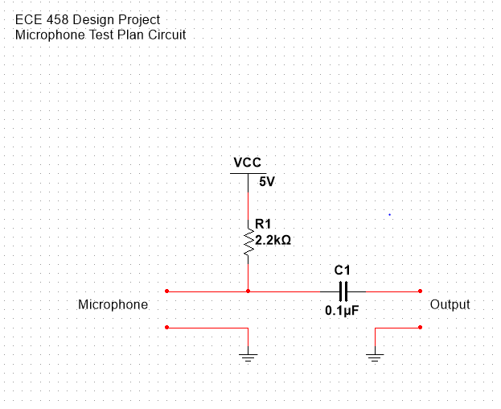

Figure 6 Microphone Circuit

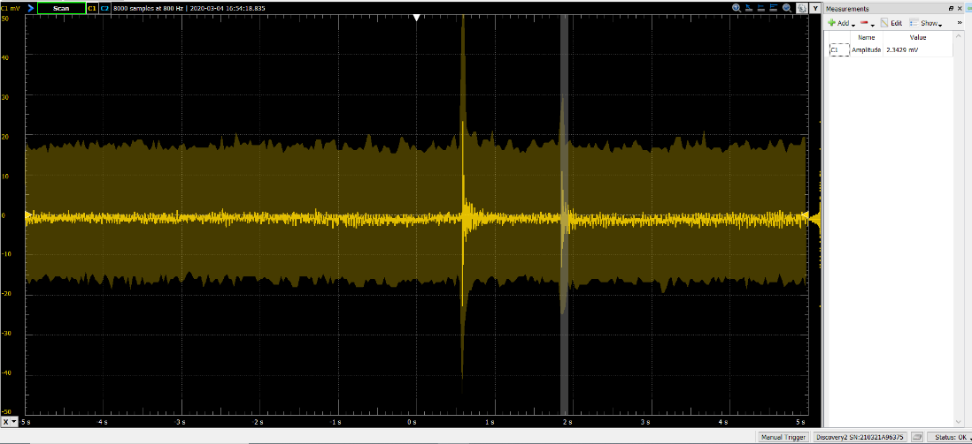

Figure 7 Microphone Test

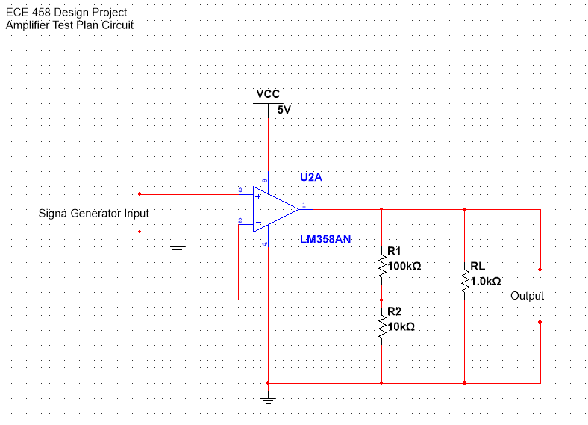

Figure 8 Amplifier Test Plan Circuit

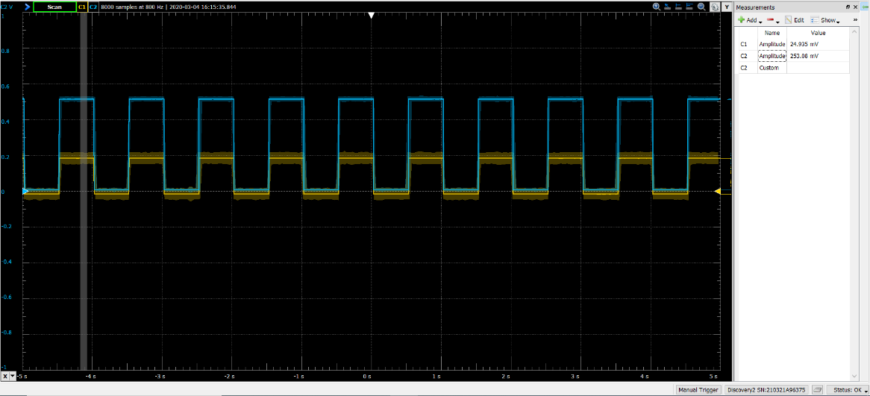

Figure 9 Amplifier 50mV Input

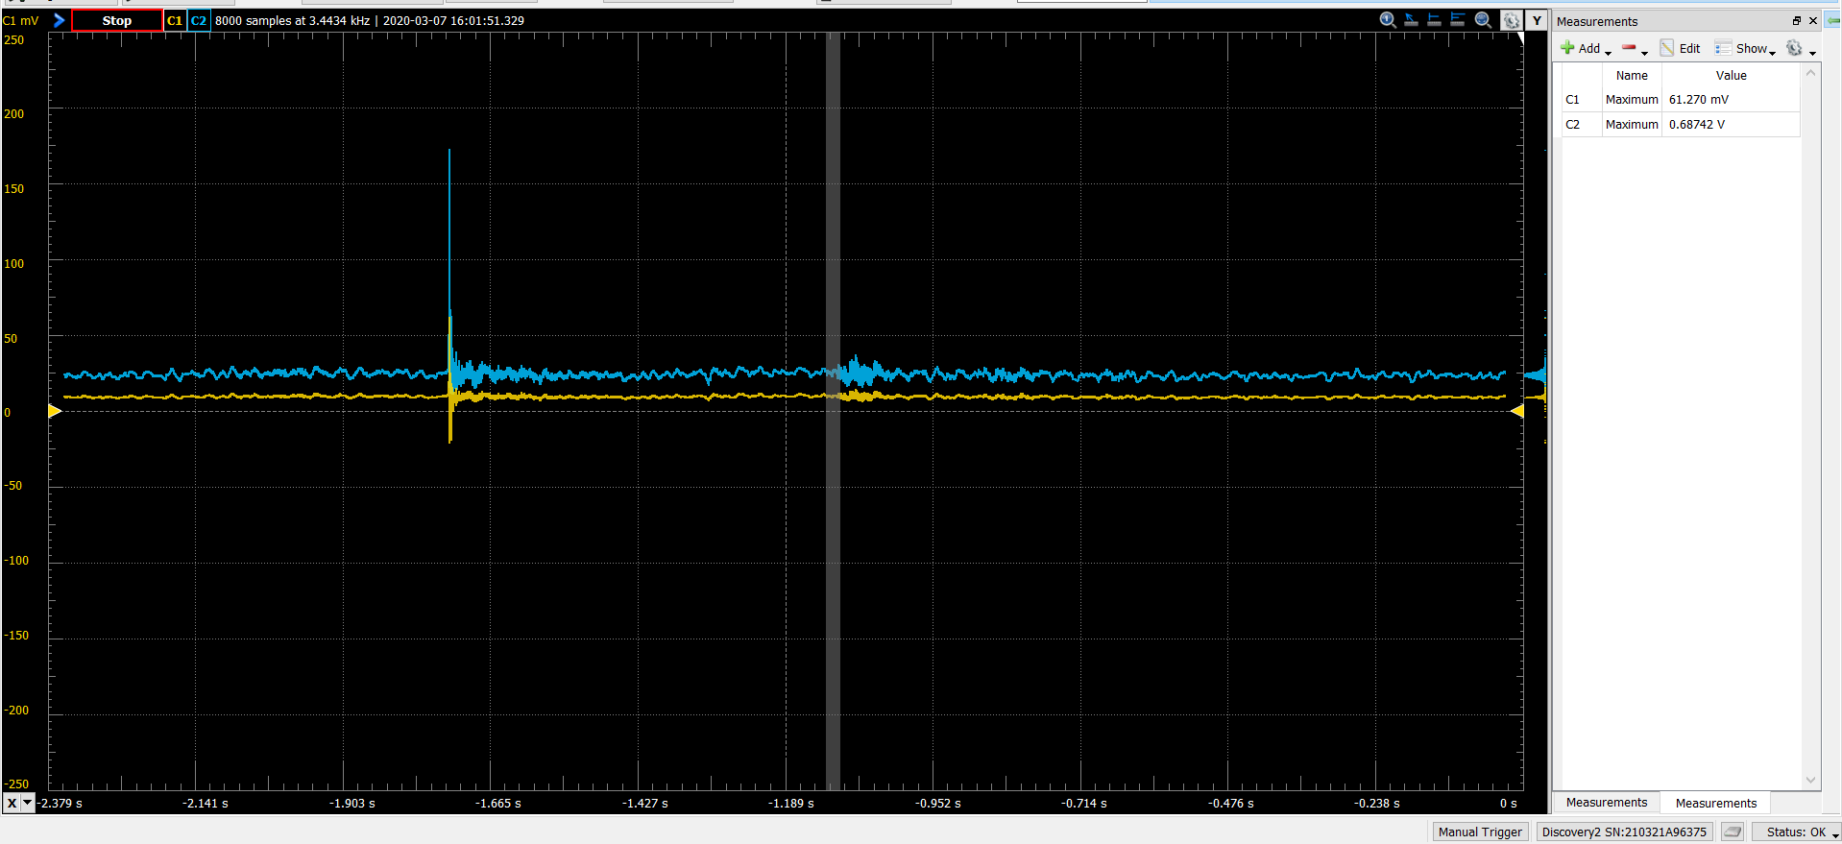

Figure 10 Microphone & Amp Integration

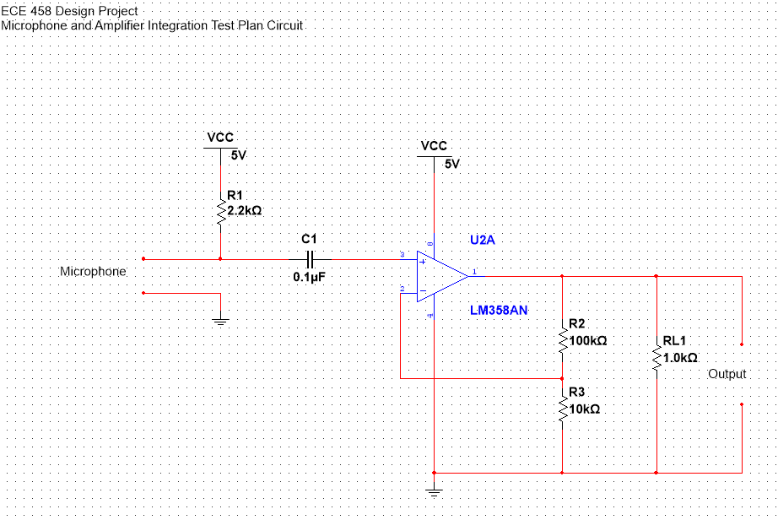

Figure 11 Microphone and Amplifier Integration Circuit

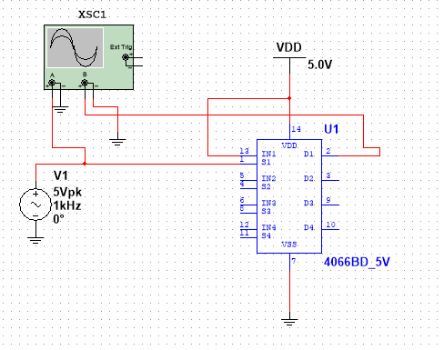

Figure 12 Digital Switch Testing Circuit

Figure 13 Auxillary Switch Test

## Figures: Processing Testing

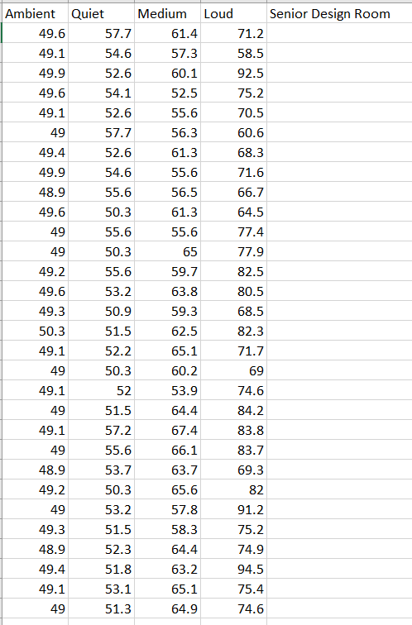

Figure 14. Data Collected using Sound Meter in One Environment

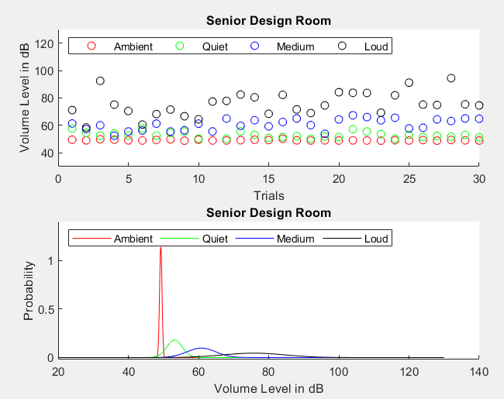

Figure 15. Data Plot with Sound Meter

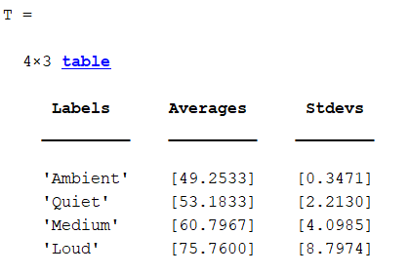

Figure 16. Standard Deviations of Environment

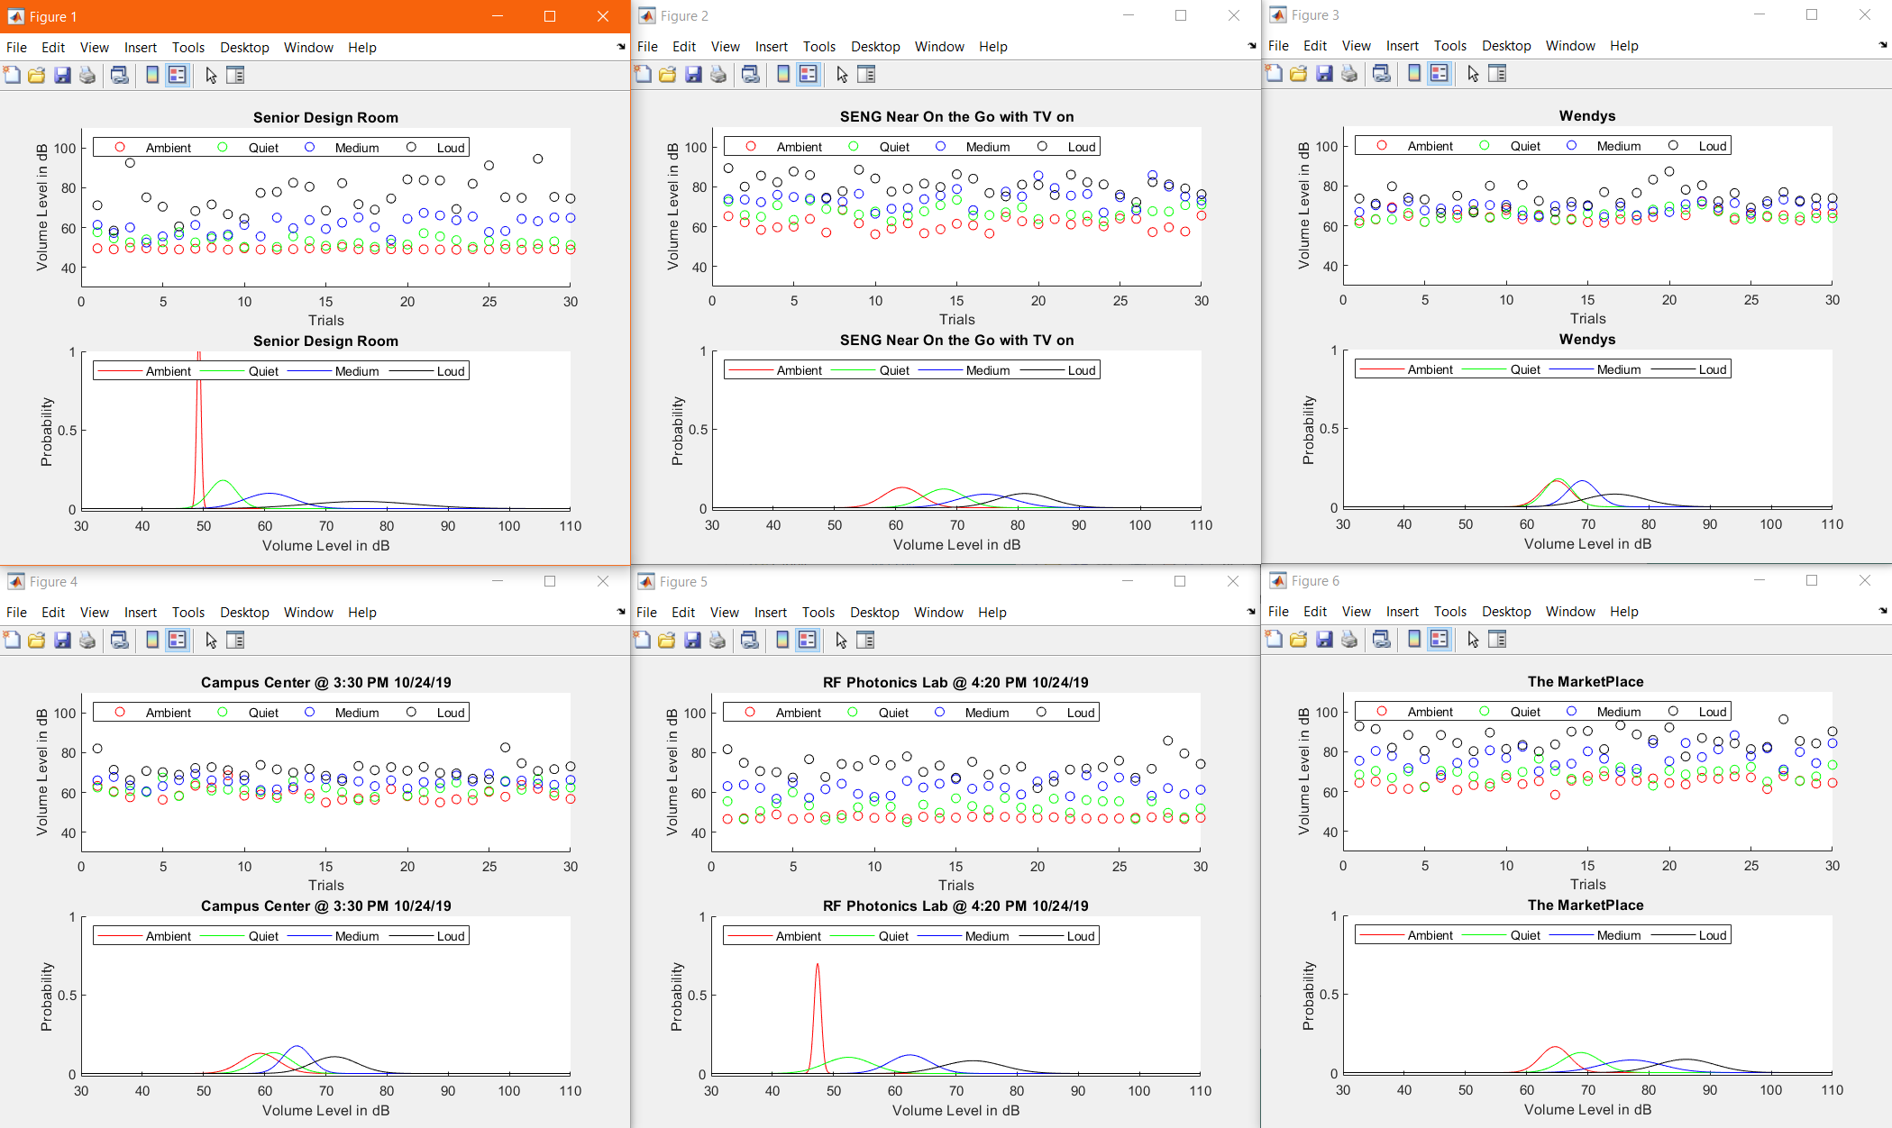

Figure 17. Multiple Environments

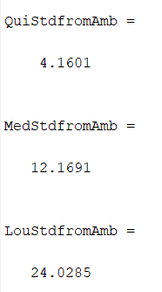

Figure 18. Average Standard Deviations of Each Threshold Level

Figure 19 Standard Deviation vs Ambient

Figure 20 Threshold based on Standard Deviation

Figure 21 PT_04 Successful Interrupt

Figure 22 30 second average vs 3 second average

Figure 20 Call Recursion

Figure 23 Iterative Averaging

Figure 24 Call Iterative

Figure 25 Recursive Average Result

Figure 26 Iterative Averaging Result

Figure 27 Recursive Methods

Figure 28 Average Timing

## Figures: Coding Testing

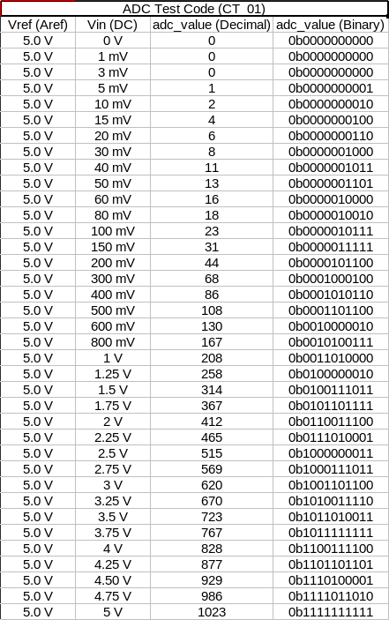

Figure 29 ADC Test Code

## Figures: Printed Circuit Board Testing

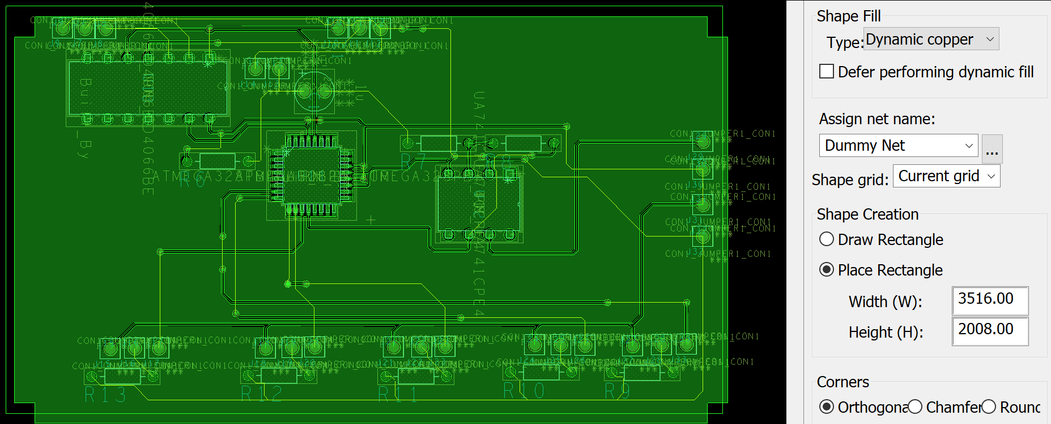

Figure 30. PCB Test Layout for Maximum Constraint Size (3500mil x 2000mil

## Figures: Enclosure Testing

A close up of text on a white background

Description generated with high confidence

Figure 31 Enclosure Outline

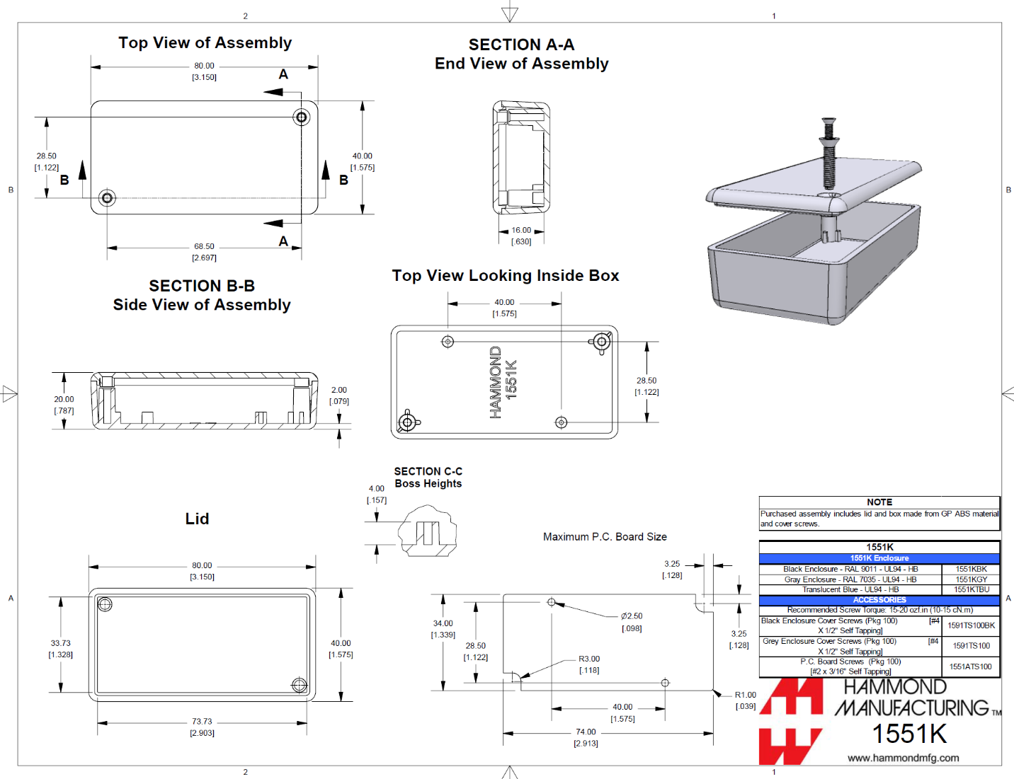

Figure 32. Selected Enclosure: Hammond 2138222

### ADC Test Code (C)

|  |
| --- |
| /* Senior Project: Test Program |
|  | * Display ADC through LEDs |
|  | * |
|  | * The goal of this program is to connect the microphone to |
|  | * the ADC on the microphone |
|  | * left signal and right signal on and off simultaniously |
|  | */ |
|  |  |
|  | #include <avr/io.h> |
|  | #include <avr/interrupt.h> |
|  |  |
|  | volatile uint16_t mic_data __attribute__((address(0x800100))); |
|  |  |
|  | void clear_ports() |
|  | { |
|  | PORTD &= 0x00; |
|  | PORTB &= 0x00; |
|  | } |
|  |  |
|  | int main() |
|  | { |
|  | mic_data = 0; |
|  | DDRC &=~ (1 << DDC5); |
|  | // PORTC0 is the input from the Microphone |
|  | DDRB |= 0x03; |
|  | DDRD |= 0xFF; |
|  | clear_ports(); |
|  | // PORTB1:0 and PORTD7:0 is the output of the Microphone. |
|  | ADMUX = (1 << REFS1)|(1 << MUX2)|(1 << MUX0); |
|  | ADCSRA |= (0b111 << ADPS0); |
|  | ADCSRA |= (1 << ADEN); |
|  | ADCSRA |= (1 << ADSC); |
|  |  |
|  | TCNT1 = 9999; |
|  | TCCR1A = (0b00<<COM1A0)|(0b00<<COM1B0)|(0b00<<WGM10); |
|  | TCCR1B = (0b00<<WGM12)|(0b101<<CS10); |
|  | TIMSK1 = (0b1<<TOIE1); // Enables interrupts for TOV1 |
|  |  |
|  | sei(); |
|  | while(1) |
|  | { |
|  | asm("NOP"); |
|  | } |
|  | } |
|  |  |
|  |  |
|  |  |
|  | ISR (TIMER1_OVF_vect) |
|  | { |
|  | clear_ports(); |
|  | TCNT1 = 9999; |
|  | mic_data = ADC; |
|  | PORTB = ((mic_data >> 8) & 0x03); // Displays the highest 2 digits of the ADC |
|  | PORTD = mic_data; // Displays the lowest 8 digits of the ADC |
|  | } |

Interrupt.cs

|  |
| --- |
| // Jared Alves |
|  | // Stephen Felix |
|  | // Michael Benker |
|  |  |
|  |  |
|  | using System; |
|  | using System.Linq; |
|  | using System.Collections.Generic; |
|  |  |
|  | namespace DSPSrDesign |
|  | { |
|  | class Program |
|  | { |
|  | static void Main(string[] args) |
|  | { |
|  | double two_avg = 0; |
|  | double twenty_avg = 0; |
|  | //double std_20 = 0; |
|  | //double T1 = 0; |
|  | //double T2 = 0; |
|  | //double T3 = 0; |
|  |  |
|  | int time = 0; |
|  | int alltime = 0; |
|  |  |
|  | int A = 4; |
|  | double Threshold; |
|  | double sd = 0; |
|  |  |
|  | double[] inputdata_two = new double[200]; |
|  | double[] inputdata_twenty = new double[10]; |
|  |  |
|  | while (true) { |
|  |  |
|  |  |
|  |  |
|  | Console.WriteLine("Time is {0} seconds", alltime); |
|  |  |
|  | Console.WriteLine("Enter a minimum value (dB) between 30 and 90:"); |
|  | string Min = Console.ReadLine(); |
|  | Console.WriteLine("Enter maximum value (dB) between 30 and 90:"); |
|  | string Max = Console.ReadLine(); |
|  |  |
|  | int Min_int = Int32.Parse(Min); |
|  | int Max_int = Int32.Parse(Max); |
|  |  |
|  |  |
|  | Random randNum = new Random(); |
|  | for (int i = 0; i < inputdata_two.Length; i++) |
|  | { |
|  | inputdata_two[i] = randNum.Next(Min_int, Max_int); |
|  | } |
|  |  |
|  |  |
|  | two_avg = inputdata_two.Average(); //Get average of random data |
|  | Console.WriteLine("The two second average is {0}", two_avg); |
|  |  |
|  |  |
|  | inputdata_twenty[time/2] = two_avg; |
|  |  |
|  | foreach (double item in inputdata_twenty) |
|  | { |
|  | Console.WriteLine(item.ToString()); |
|  | } |
|  | Threshold= A*sd + twenty_avg; |
|  |  |
|  | if (alltime > 20) |
|  | { |
|  | if (two_avg >= Threshold) |
|  | { |
|  | alltime = -2; |
|  |  |
|  | Console.WriteLine("Interrupt has occurred"); |
|  | } |
|  | } |
|  |  |
|  | if (alltime >= 20) |
|  | { |
|  |  |
|  |  |
|  | twenty_avg = inputdata_twenty.Average(); |
|  | Console.WriteLine("The twenty second average is {0}", twenty_avg); |
|  |  |
|  | double sumOfSquaresOfDifferences = inputdata_twenty.Select(val => (val - twenty_avg) * (val - twenty_avg)).Sum(); |
|  | sd = Math.Sqrt(sumOfSquaresOfDifferences / inputdata_twenty.Length); |
|  | Console.WriteLine("The twenty second standard deviation is {0}", sd); |
|  |  |
|  | } |
|  |  |
|  |  |
|  | Console.WriteLine("------------------------------------------\n \n"); |
|  | alltime = alltime + 2; |
|  | if (time < 18) |
|  | { |
|  | time = time + 2; |
|  | } |
|  | else |
|  | { |
|  | time = 0; |
|  | } |
|  |  |
|  |  |
|  | } |
|  | } |
|  | } |
|  | } |

